**Design and Implementation of a Co-operative System for Baze University Staff**

**BY**

Anikwenze Olisa Harry

BU/21C/IT/5648

**IN PARTIAL FULFILMENT OF THE REQUIREMENT FOR THE AWARD OF BACHELOR OF SCIENCE IN SOFTWARE ENGINEERING, FACULTY OF COMPUTING AND APPLIED SCIENCE, BAZE UNIVERSITY, ABUJA.**

SEPTEMBER 2024

# **DECLARATION**

I hereby declare that this research project has been written by me under the supervision of Dr. Usman Bello Abubakar. The work has been presented in any previous research for the award of B.Sc degree to the best of my knowledge. The work is entirely mine and I accept the sole responsibility for any errors that might be found in the work, while the reference to publish material have been duly acknowledge.

______________________________ _______________

Anikwenze Olisa Harry Date

BU/21C/IT/5648

APPROVED BY

_____________________

Head of Department,

Department of Computer Science

# **CERTIFICATION**

This project entitled “**Design and Implementation of a Co-operative System for Baze University Staff”** meets the requirements governing the award of Bachelor of Science in Software Engineering in Baze University, Abuja.

# **APPROVAL**

This is to certify that the research work title “**Design and Implementation of a Co-operative System for Baze University Staff”** by Anikwenze Olisa Harry with BU/21C/IT/5648 has been approved by the Department of Computer Science, Faculty of Computing and Applied Science, Baze University, Abuja, Nigeria.

By

Dr Usman Bello Abubakar

Supervisor Date

Dr Usman Idris Abubakar

Head of Department Date

Prof Helen Negbenebor

Dean, Faculty of Computing and Applied Science Date

Prof Choji Davou Nyap

External Examiner Date

# **DEDICATION**

I am only where I am today and can only move forward by God’s Grace who this project is dedicated to firstly, he has imbued me with the strength to overcome all the difficulties I have faced, allowed me to attend a university like Baze and blessed me with my friends and family. For this and more, I will forever be grateful and dedicated to him. I would also like to thank my family members, my parents Mrs. UzoAmaka Anikwenze and Engr. Bartholomew Ndubisi Anikwenze, they have made a lot of sacrifices for me, and I would not be able to complete this project without their love and support. Big thanks go to my sisters next, Jennifer, Sophie and Sonia. They have always believed in me and told me I can do anything I set my mind to even in my lowest moments, thank you for your love and always staying by my side. Thanks also go to my Uncle Mr. Emeka, thank you for your unwavering support.

I would also like to express my gratitude to my friends for the support I have received from them including but not limited to Ussah Nuhu-kwache, Emerald Akhaumere, Ammar Baba-Ahmed, Fadimatu Musa, Eldad Akhaumere, Bethel George-Nwaeke, Pochita Nerat Nwajah, Samuel Chimebuka Okorie,Collins Garba, Nafisat Muhammad, Hafsat Abbas Jega, AbdulWahab Uthman Mohammed, Iwuanoruo Osinachi, Tobenna Oguebie, Munira Bodoo, Remi Bakare, Abdallah Ibrahim, Maryam Umar, Aliyu wakama,Teslim Kayode, Zayyad Rumah lawal, Mohammed Dayyib Abdullahi, Favour Onyekachi, Blessing Onyekachi, Mujahid Adebisi, Oghenetega Ighomuaye Alvin, Maryam Saidu.

And to my wonderful friends outside school, Fajimi Wuraola, Angel Akpoveso, Demilade Olagungu, Daniel Asuquo. Thank you for listening to me during trying times.

# **ACKNOWLEDMENT**

My appreciation goes to whole faculty of Computing and Applied Science, especially the Software Engineering and Computer Science department. The lecturers and students have driven me to always strive for academic greatness.

Special thanks go to me supervisor, Mr. Usman Abubakar Bello, thank you for guiding me through this process and not giving up on me. Thanks also go to my former supervisor Dr. Moses Ubaru for guiding me up to the point where he did, I am grateful for all his efforts.

I would also like to express my gratitude to my faculty’s Head of Department, Dr. Usman Idris Abubakar for always listening to our complaints as students and encouraging a conducive learning environment.

I would like to thank the members of my department with whom I have completed this degree.

Next, I would like to thank the staff of Baze University who have looked out for me in some way or the other, both those in the computing and Applied sciences faculty, and other faculties, some include- Mrs. Mercy Johnson, Miss Khadijah Saad Mohammed, Mr. Gilbert George, Dr. Julius Makinde, Dr. Daniel, Dr. Mrs. Esther Omanayin, Dr. Lawrence Moralake, Dr. Charles Isah Saidu, Prof. Peter Ogedebe, Mr. Muhammad Shafi’u Shehu, Mrs. Mubarakah, Mrs. Ruqayya Muhammad, Mr. Tijani. Every one of my lecturers have supported me through my stay in this institution and I am eternally grateful, thank you for your support, love, and faith.

# **ABSTRACT**

In a time where technology is rapidly advancing, co-operative societies need to be carried along by digitalizing their activities, transforming their manual activities to follow a more technological based system. The applications being developed include a web application and a mobile application. The mobile application is s user friendly system that allows members to perform their regular activities on the go like requesting for loans, always viewing their loan status and balance. The web app will allow the admin to oversee activities performed on the system and swiftly act in the occurrence of certain events. Our developed system is tailored to meet the needs of the co-operative society managed by Baze University to streamline their activities.

Table of Contents

**DECLARATION** ii

**CERTIFICATION** iii

**APPROVAL** iv

**DEDICATION** v

**ACKNOWLEDMENT** vi

**ABSTRACT** vii

**LIST OF TABLES** xi

**LIST OF FIGURES** xii

DEFINITION OF TERMS xiv

**CHAPTER 1** 1

**INTRODUCTION** 1

1.1 Overview 1

1.2 Background and Motivation 1

1.3 Statement of the Problem 2

1.4 Aim and Objectives 2

1.5 Significance of the Project 3

1.6 Project Risks Assessment 3

**1.7** **Project Organization** 5

**CHAPTER 2** 6

**LITERATURE REVIEW** 6

**2.1** **Introduction** 6

**2.2 Historical Overview** 6

**2.3 Related Work** 10

**2.4 Summary** 14

**REQUIREMENTS, ANALYSIS, AND DESIGN** 17

**3.1** **Overview** 17

**3.2** **Adopted Methodology** 17

**3.2.1 Data Gathering Method 1 (interview)** 17

**3.3** **Tools and Techniques** 18

**3.4** **Ethical Consideration** 18

**3.5** **Requirements Analysis** 20

**3.5.1** **Functional Requirements Specifications** 20

**3.5.2** **Non-Functional Requirement Specifications** 21

**3.5.3** **System Requirements Specifications** 22

**3.6 System Design** 22

**3.6.1 Application Architecture** 23

**3.6.2 Use case diagram** 25

**3.6.3** **Entity-Relationship Diagram (ERD)** 29

**3.6.4 Data Design** 30

**3.6.5 Activity Diagrams** 33

**3.8.5** **Data Flow Diagram** 37

**3.6.6** **Control Flow Diagram** 39

**3.6.7 User Interface Design** 40

Chapter 4 44

Testing and Implementation 44

4.1 Overview 44

4.2 Main Features 44

**4.3 Implementation Problems** 63

**4.4** **Overcoming Implementation Problems** 63

**4.5** **Testing** 64

**4.5.1 Test Plans (for Unit, Integration and System Testing)** 64

**4.5.2** **Test Suite (for Unit Testing, Integration Testing, and System Testing)** 66

**4.5.3** **Test Traceability Matrix (for Unit Testing, Integration Testing, and System Testing)** 66

**4.5.4** **Test Report Summary (for Unit Testing, Integration Testing, and System Testing)** 69

**4.6** **Use Guide** 70

**4.7** **Summary** 72

**CHAPTER 5: DISCUSSION, CONCLUSION, AND RECOMMENDATIONS** 73

**5.1** **Overview** 73

**5.2** **Objective Assessment** 73

**5.3** **Limitations and Challenges** 73

**5.4 Future Enhancements** 74

**5.5** **Recommendations** 74

**5.6** **Summary** 74

**REFERENCES** 75

**Appendix A - Project Document** 79

**Appendix B – Interview** 80

**Appendix C- Source Codes 81**

# **LIST OF TABLES**

Table 1.1- potential risks faced by the system ………………………………………………………4

Table 2.1 related works summary …….……………………………………………………14

Table 3.1 functional requirements of the members …………………………………………20

Table 3.2 functional requirements of the executives ………………………………………… 20

Table 3.3 functional requirements of the admin …………………………………………20

Table 3.4 Non-functional requirements …………………………………………21

Table 3.5 systems requirements …………………………………………22

Table 3.6 Data dictionary for member table …………………………………………30

Table 3.7 Data dictionary for admin table …………………………………………30

Table 3.8 Data dictionary for loan table …………………………………………31

Table 3.9 Data dictionary for activities table …………………………………………31

Table 3.10 Data dictionary for loans table …………………………………………32

Table 3.11 Data dictionary for registration table …………………………………………32

# **LIST OF FIGURES**

FIGURE 2.1- user interface of Co-opify …………………………………………………..**12**

FIGURE 2.2- user interface of Co-opco ………………………………………………….. **13**

FIGURE 3.1- APPLICATION DIAGRAM ……………………………………………….**24**

FIGURE 3.2 Use case Diagram ……….…………………………………………………..**26**

FIGURE 3.3 Entity Relationship Diagram ………………………………………………..**29**

FIGURE 3.4 Activity diagram for login of a user …………………………………………..**34**

FIGURE 3.5 Activity diagram for the registration of a user ……………………………..**35**

FIGURE 3.6 Activity diagram for the loan request of a user ……………………………..**36**

FIGURE 3.7 Activity diagram for changing of passwords by a user………………………..**37**

FIGURE 3.8 Data flow diagram for the registration of a user……………………………..  **38**

FIGURE 3.9 Data flow diagram for the login of a user …………………………….. **38**

FIGURE 3.10 Data flow diagram for the loan request of a user………………………….. **38**

FIGURE 3.11 Control flow diagram for the registration of a user…………………………..**39**

FIGURE 3.12 loading page ……………………………………………………………….. **40**

FIGURE 3.13 login page ……………………………………………………………….. **40**

FIGURE 3.14 registration page …………………………………………………………….. **41**

FIGURE 3.15 dashboard page …………………………………………………………….. **41**

FIGURE 3.16 loan request page…………………………………………………………….. **42**

FIGURE 3.14 Activities page……………………………………………………………….. **42**

# **CHAPTER 1**

# **INTRODUCTION**

## 1.1 Overview

The System once fully developed, will provide a simple interface for the co-operative members to carry out their numerous activities -activities which will be properly covered later in the chapters- providing a secure, easy to use and efficient system with modern software development technologies to promote the saving of funds (at least monthly) among members. In this chapter, we will look at the expectations from the proposed system and a general overview of the problem which required the development of this system.

## 1.2 Background and Motivation

A co-operative society follows a system where a group of individuals come together and gather resources to reach mutually shared economic and social goals. It has become common practice for such societies to be found in the hearts of workplaces, allowing staff who decide to be members of the co-operative to help each other financially maybe by starting businesses together where profits will be split, or by contributing a certain amount over a certain time frame from which loans can be taken out of.

The organization concerned with this project is Baze University. It is a tertiary educational institution -located at Plot 686 Cadastral Zone C00, Kuchigoro, Abuja- and just like numerous organizations, has a properly functioning co-operative society where any of the staff whether academic or non-academic may join the society to enjoy the benefits it offers its members.

This system will greatly lessen the burden carried by the society’s executive team in the case of validating registration or even approving loans; and even those levied upon its members like in the case of requesting for loans.

## 1.3 Statement of the Problem

At Baze University, we are still trying to fuse technologies with our everyday activities to enhance efficiency and this case is no different; the co-operative society faces a problem since they currently lack a digital platform to perform their numerous activities. The prior statement shouldn’t lead to the conclusion that there is no technological structure in place now as there is a digital database that stores the staff-member details. But this is not enough. Members have no way to quickly see an accurate representation of their loan or savings balance at any given time or from any location including from bed when they wake up first thing in the morning; Or even when loans they’ve taken out are due for payment.

There is also the persistent issue of some requests, be it registration requests, loan requests etc. Not being attended to in the order of which they were made. Members have made complaints of their loan requests remaining unattended to for extended periods while others have already been sorted out; This shouldn’t lead to the assumption that staff are incompetent but rather should enforce the idea that there is a crucial need for the system to promote the efficiency and integrity of the co-operative.

Looking at the issues that the executive board face, they aren’t always able to stay on top of who has/hasn’t made their monthly contributions or keep track of all members and their status. They could be given real time notifications through emails about most activities on the system that would require their attention.

## 1.4 Aim and Objectives

The aim of this project is to create a system to support the operations of the Baze University Co-operative society; thereby improving its efficiency, reliability, accessibility, and organization.

The objectives of the system-

1. To Allow members of the Co-operative to request loans.
2. To allow executive members to approve/decline loan requests and registration requests.
3. To allow the admin to suspend or activate members.

## 1.5 Significance of the Project

The completion of the co-operative society system will revolutionize the existing system now for all members of the co-operative society by employing modern technologies to give a safe and enjoyable experience.

Below, the benefits have been outlined-

1. **Faster decision making among the executive board**: an equal amount of voting power is given to each member of the co-operative, and they will be able give their individual votes at any time and from any location on their devices so that when the votes are accumulated, a task may or may not be carried out. The system looks at removing the constraints that may require the executive members to meet physically to give vote (to authorize a process), and the execution of that process (once votes are given, activity is carried out).
2. **Streamline the loan request process:** instead of requiring all members to visit the office to make loan requests, with the new system, members will request loans on the application. Not just can they make requests, but they will also be able to manage their loans (see the loan status which may have been approved, declined or pending. They can also see the deadline for approved loans and how much is left to upset the loan) upon approval or decline, they will be notified through mail.
3. Provide a webapp that allows the admin to have an overview of all contributions, withdrawals, registrations etc. that have been carried out on the system given a certain period. The admin will be able to oversee all the necessary information and activities on the system. The information gathered can be used to make decisions for the growth and improvement of the co-operative.

## 1.6 Project Risks Assessment

After careful analysis, the possible risks faced by the system are outlined below-

**Table 1.1-** Risk Assessment

|  |  |  |
| --- | --- | --- |
| **RISK** | **RISK MITIGATION** | **IMPACT** |
| Equipment failure hindering the software development process | The entire folder containing the projects documentation has been backed up to Microsoft’s OneDrive. As of this time, the system is yet to be developed; but once the process in ongoing, it will also be backed up to the cloud. | MODERATE |
| Equipment Loss potentially causing loss of work | The security of the device which the app is being stored on will be ensured; in addition to backing up work both to the cloud and hardware devices (flash drives etc.) | MODERATE |
| Unavailability of Essential software | During the requirement gathering stage, required software will be identified and its availability will be considered. If not available, alternative means will be explored. | HIGH |
| **Data Security breaches** | measures to ensure security of the system and information is accessible only to the individual who owns it will be implemented. The admin does not have access to information that may be used to identify a particular member, and neither can they modify a member’s details. | HIGH |
| **Coding issues (**low quality code**)** | Appropriate tests will be carried out to ensure usability and efficiency of the system. | HIGH |
| **Risks associated with Law and Compliance** | Proper referencing and citation will be made to any work that has contributed in any-way to the completion of this project. | HIGH |

## **1.7 Project Organization**

Within this document, we will find material detailing the activities and the processes that led to the development of a web and mobile application to support the activities of Baze University’s co-operative society.

The later chapters will cover the designated topics identified below:

Chapter 2: Literature Review

Looks at existing works related to a co-operative society’s management system.

Chapter 3: Methodology

This chapter will discuss the tools, techniques and frameworks that have been used in the development of the project. Including the system architecture, flow of activities, system requirements etc.

Chapter 4: Implementation and Testing

In this chapter, details of the application development are defined. The applications code for the front-end and back-end including test cases and how the system performed in these cases will be outline.

Chapter 5: Conclusion

Summary of the project including its areas for potential improvement and key findings.

# **CHAPTER 2**

# **LITERATURE REVIEW**

## **2.1 Introduction**

In this chapter, we will find the literature review of the techniques used in this thesis. Details on past works that have been reviewed in relation to the project development, we will also look at literature on the technologies use i.e. NodeJS, React Native, MongoDB etc. and how they were used to address the issues raised in the previous chapter. This chapter will also delve into the impact technology has on co-operative societies.

## **2.2 Historical Overview**

Humans have always made major breakthroughs or achieved incredible feats due to the collective effort of some kind of community where each sector plays a crucial role and delivers accordingly, even for large scale systems, the final product is a result of a well working or managed community/society. This can be linked to the popular saying that “No Man Is an Island” coined by John Donne in 1624 and just tries to say that no man is better 4off on his own completely as everyone is a piece of the greater whole which is humanity itself (Seffusatti, 2024).

A co-operative society is built on similar principles, giving its members room to grow and carry out personal projects only possible with the combined efforts of the society. To give the members of the co-operative a digital platform to carry out their activities, this system makes use of proper cloud-based technologies to ensure appropriate features will be available to all members.

Over some years, great effort and work have gone towards research on how the use of computers and ICT technologies may be leveraged by co-operative societies in their day-to-day activities including registration of their members, monitoring of loan requests and active loans and all other operations performable within or outside the society. Some researchers aim to have a centralized system that keeps track of the operations of all co-operatives in Nigeria using a centralized system which will reduce the number of hours spent on manual computations of their activities (Olorunlomerue et al, 2017).er

**2.2.1 Earliest record of the Co-operative movement (1700s)**

Record on co-operative societies dates to 1761 in Fenwick, Scotland during a time when there was a decline in handloom weaving attributed to the sudden rise in addition of machines in the textile industry, the society was established for weavers to support each other to regulate price for the work, with the terms for being in the society including being honest to each other and to their employers (National Library of Scotland, 2023). While the initial cause for the co-operatives establishment was to give a society for weavers to support each other, in November 1769, the members of the co-operative wanted non-members to also benefit from their activities by using funds generated by the society to buy food in bulk that will be sold to both members and non-members but in smaller quantities and a slashed price. This gave non-members a cheaper alternative and gave another income source to the society members as the savings would be split amongst them (Carrell, 2007). This was during a time long before the first computer was introduced, the activities of the society was greatly impeded. The printing press was used to spread information across wide areas while most kinds of transactions would have to be carried out manually, thereby slowing down their operations.

**2.2.2 The Technology Boom (1800s)**

After a long time of co-operatives running their operations manually, slowly they started to make use of modern-day technologies; like with the use of transport networks to cover wider ground and grow their member base, they also made use of the telegraph to better communicate within the society or facilitate better communication with other societies allowing them to share good practices (Muller & Tworek, 2015). With less need for the use of manpower for some operations, the co-operatives were able to invest more time in their societies to increase productivity and value to both members and non-members

**2.2.3 Emergence of Online Platforms (20th Century)**

With the introduction of web-based technologies in the 20th century, the co-operatives were only strengthened further. With online applications making it easier for members of the societies to collaborate and communicate by abolishing the barrier of geographical location (Wegner et al., 2023).

**2.2.4 Interactive Collaboration**

This advancement also meant that the societies were able to cut costs in some area by leveraging on the use cases that the platforms come with. There was less need for paper works, physical meetings as they could be hosted online, and other dated methods of communication and forms of management (Atanasova et al, 2024).

**2.2.5 Increased Technology Accessibility (Late 2000s - Present)**

With the launch of the Apple app store and the ever-growing popularity of web applications, it marked a turning point (Goray, 2024). Co-operatives are now more equipped with technology that allows all their members to perform operations on the go. Smartphones have now become a core part of our everyday lives with almost everyone owning one, with about 7.2billion smartphones in circulation (Howart, 2024) there is a high chance each member has access to a smart phone. This means systems that support the operations of the co-operative can easily be loaded and accessed by members on their smartphones at almost any time. The systems are also more usable by members with special needs with features like text-to-speech, screen reading, and even language translation.

Another area where the use of technology shines is with the administrator’s management of the society. The admin may now better track the activities within the cooperative thereby improving transparency and accountability from all members (Sobolev et al, 2023).

All these advancements in technology have made it possible to develop mobile and web applications that use cutting-edge cloud computing to offer interactive and responsive applications available across different platforms.

The technologies used in this work include:

1. **React:** React is a popular JavaScript framework that employs Webpack to compile React, JSX and ES6 code and handles CSS file prefixes. It is mostly used because of its easy creation of dynamic applications which greatly supports code reusability with their components that can be custom made and reduces overall development time, it’s improved performance with Virtual-DOM that updates related items when states in the browser are updated (Deshpande, 2024).
2. **Cascading Style Sheet (CSS)**: CSS was developed by the world wide web consortium(W3C) and it’s used to style elements written in markup languages like HTML. This allows developers to create visually appealing interfaces (Domantas, 2023).
3. **React Native:** React Native is a JavaScript mobile app framework that allows development of mobile applications for IOS and Android. React Native was built on React with several similarities allowing developers who are familiar with JavaScript and React to quickly pick it up (Budzinski, 2024). It has been used for the development of mobile applications and has been hosted on expo go which is a cross-platform application for building mobile applications for IOS and Android.
4. **MongoDB:** MongoDB is a NoSQL database management program that is used as an alternative to traditional databases (Gillis, 2023). MongoDB is popular among developers because of the NoSQL format that appears very similar to JavaScript objects therefore giving developers a familiar feel as the same concepts can be applied to them.

Some features of MongoDB –

1. **Replication:** replicas in MongoDB are set of processes that are used to reduce redundancy and to increase availability by creating copies of the data onto a server (Gillis, 2023).
2. **Scalability:** with horizontal scaling which allows you to add servers to your cluster, and vertical scaling which aims to add more power to a machine, MongoDB benefits large systems with high traffic (Saini, 2024).
3. **Load balancing.** MongoDB uses software to dissipate network traffic without a hardware load balancer because of its support for vertical and horizontal scaling.
4. **Schema-less:**  MongoDB uses a scheme-less database meaning that one collection may hold different kinds of documents in it, the documents stored in the same collection must not have the same properties or size (Saini, 2024).
5. **Document Oriented:** MongoDB stores records in key-value pairs as it’s a No-SQL database. This is a more familiar with developers as records are represented inn JSON which many developers are more familiar with this structure.

## **2.3 Related Work**

Some individuals have been able to complete the development of digital systems to support co-operative societies in Nigeria as most existing systems support foreign accounts. Some of these systems include, (Olorunlomerue et al, 2017) who proposed a web-application system for handling records of cooperative societies in Nigeria. They used Java and MySql to build the system which was meant to be used to register co-operative societies in Nigeria to enable the Government to collect data on co-operatives for proper planning.

Still in 2017, (Onyeama et al, 2017) completed the development of a system designed to manage short-term and long-term loans. The system also kept tract of the inflow and outflow of cash within and outside a cooperative society. To build the system, they used CSS and HTML at the front end and PHP and MySQL for the backend. The project was said to allow investors to easily retrieve relevant information about the cooperative. In 2020, (Yusuff et al, 2020) embarked on a study to investigate how ICT in its appraised form was used in co-operative societies. The study included some tertiary institutions in Osun State but did not include the development of any solution or application for the societies. Research that was conducted in Indonesia by (Andreansyah & Rizkiana, 2020) took on the development of a web application that was to keep track of employees’ salaries in the co-operative using the incremental model.

(Oluyombo, 2013) took interest in how co-operative society loans met the financial needs of their members in rural areas, while his research did not seek to find ways ICT would solve co-operative loan management, it further highlighted the issues with managing the loans manually and can be used to see the crucial need of a digital revolution in the area.

Meanwhile, (Mbam & Igboji, 2013) took on the project of developing a system that will aid a co-operative society’s loan management process including short-term and long-term loans. MySQL server was used for the database with Visual Basic net framework on the frontend. Overall, the system failed because investors failed to see an area where the system was operational.

A potent research and project were conducted by (Caroline, 2018) where a loan cooperative information system in the form of a web application was developed for Cempaka cooperative. The project aimed to build an information system using a rapid prototyping, PHP and MySQL were used on the backend with HTML on the front-end. The finished system consisted of numerous capabilities including, savings and loan transactions, loan instalment transactions, cash withdrawal transaction etc. Another notable project was completed in 2021 (Moechammad et al, 2021) where the authors developed an android application to manage the savings and loans of a cooperative to enable its members to save and raise capital for the cooperatives business capital. They took on the project because it was found that while technology plays a crucial role on storing and processing data, cooperatives in Indonesia were yet to leverage on this advantage. The society the application was built for “Permata Ngijo Savings and Loans Cooperative” consisted of 30 active members and was run by several executives. The development of the project followed a prototype system developer method where the Unified modelling language (UML) was used to design the system, MySQL was used for the database structure with a black-box testing for system testing and PHP for the backend.

(Pane, 2019) took on a project to create an information system for a savings and loan cooperative system in the form of a web-application for the Pancuran Hidup Credit Union. The system employed the waterfall model to create a savings and loan information system that allowed the employees to manage their loan and savings data making it easier to report more accurate data to them.

**Co-opify**

Coopify is a web-based application that aims to provide a system that meets the needs of different co-operatives societies

**Features**

1. There are numerous features on the system. from adding members, requesting for loans and adding savings.
2. The admin has an overview of the system activities and directly manages the system.
3. Broadcasts can be made to third party apps like WhatsApp to alert members on any events.

**Limitations**

* 1. There is no login for the members as the admin must perform actions on the members behalf.
  2. There are a lot of features that are very niche and unnecessary to most co-operatives, making the system seem clustered with unnecessary features.
  3. The admin must manually send messages on the supported third-party applications to send messages to other members.
  4. Nigerian Prominent banks do not seem to be supported as some didn’t come up during registration.
  5. Since the system requires you to fill in all bank information relating to the co-operative, it poses great financial risks.

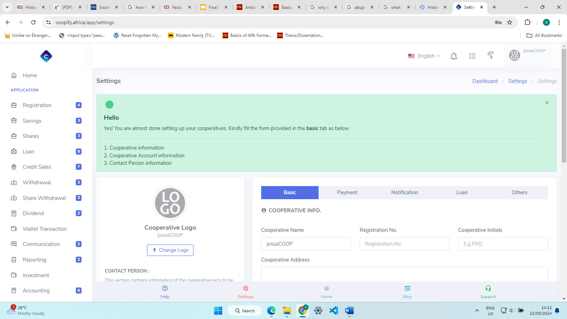

**Figure 2.1 User Interface of Co-opify**

**COOPco**

**Features**

* 1. Loan Requests
  2. Said to support member registration

**Limitations**

This system does not support any free trials with the lowest tier starting at $10 (US Dollar)/month. The registration process for a live demo kept falling through and some input fields accepted wrong inputs e.g. a phone number field accepting string characters. All these show signs of a poorly managed system.

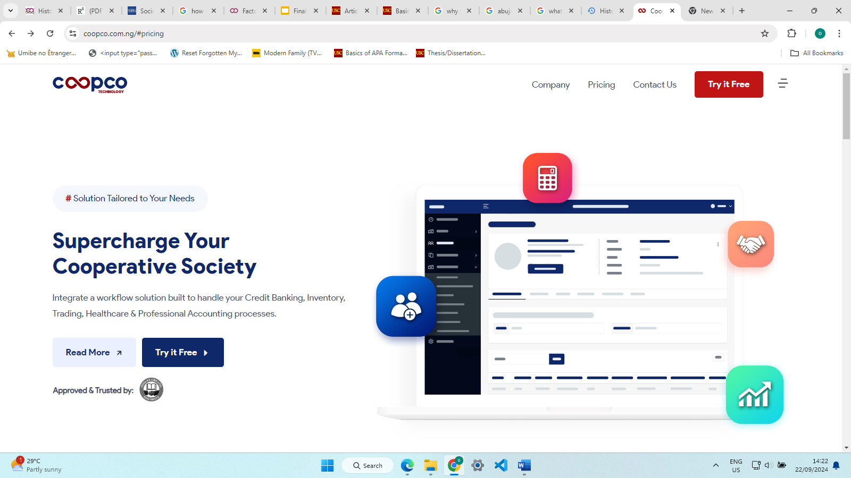

**Figure 2.2 User Interface of COOPco**

**Electric Cooperatives FCU (mobile application)**

**Features**

1. Allows users to see their account balance at any time.
2. Users can view and pay bills
3. Users can see recent transactions

**Limitations**

1. Only foreign banks seem to be supported on the application.
2. It is more of a personal banking application than suited for a co-operative society.

## **2.4 Summary**

This chapter showed the review process of the literature regarding the numerous technologies and resources used through the development process. The Historical overview shows how co-operative societies have been able to evolve over the years mainly to the rapid development of technology.

The cooperative society being developed takes these issues into account and strives to provide solutions that are tailored to the needs of the co-operative society of Baze University.

Chapter 3 will delve into the requirements analysis and the methodology that has been used to solve the stated issue, including the provision of diagrams like the Use case, Activity. ERD etc.

**Table 2.1 related works summary**

|  |  |  |  |
| --- | --- | --- | --- |
| **S/N** | **App Name/Authors name** | **Features** | **Limitations** |
| 1 | Co-opify | Allows, requesting for loans and adding savings.  Admin directly manages the system.  There is provision for communication with members. | Admin performs activities on behalf of members.  Oversaturation of features that are not necessary to a cooperative.  Communication with members could be easier. |
| 2 | Co-opco | Loan Requests  Said to support member registration | Poorly managed system  Does not offer a free version to test the app |
| 3 | Electric Cooperatives FCU | users can see their account balance at any time.  Users can view and pay bills  Users can see recent transactions | The system is more suited as a personal banking application and doesn’t allow collaboration among members. |
| 4 | (Olorunlomerue et al, 2017) | Registration of co-operatives on a national level | The system wasn’t scalable enough to store data on the whole country |
| 5 | (Onyeama et al, 2017) | Management of short- and long-term loans  The developed system will monitor the cash outflow and inflow of the co-operative. | There was high Complexity in monitoring all loans |
| 6 | (Yusuff et al, 2020) | Research on impact of ICT to co-operative societies | The developed system didn’t provide any solution to the raised issues |
| 7 | (Mbam & Igboji, 2013) | Management of short- and long-term loans | A good Use case for system was failed to be seen by investors |
| 8 | (Caroline, 2018) | Development of a web app to monitor savings and loan transactions, cash withdrawals | The project could only be used by the specific organization |
| 9 | (Pane, 2019) | Allows members to track their loan and savings information for easier data reports | Scope creep led to the project to not be finished |
| 10 | (Andreansyah & Rizkiana, 2020) | Developed system kept track of employee’s salaries | The developed system did not provide enough technical features to meet the demands of the co-operative |
| 11 | (Moechammad et al, 2021) | The system kept track of the savings and loan activities for the cooperative | The system could not perform any other activities apart from keeping track of the financial activities. Meaning that other operations like registrations were still manual. |

**CHAPTER 3**

# **REQUIREMENTS, ANALYSIS, AND DESIGN**

## **3.1 Overview**

This chapter will give an overview of the analysis carried out on the system to gather the requirements for the system (including the methods to gather these requirements). The methodology with its required steps will also be discussed. A general view of the design of the proposed system should be expected.

## **3.2 Adopted Methodology**

The development of the proposed project adopted the Rapid Application Development model. This methodology was chosen due to its huge emphasis on user involvement during the software development process, which helps to reduce the risk of project failure. The requirements will be properly gathered, but during the development process, the developer doesn’t follow a definite set of requirements, instead they create multiple prototypes as fast as they can and show it to the client to identify what they like and what they don’t (“What is Rapid Application Development (RAD)? An Ultimate Guide for 2024”, 2024).

### **3.2.1 Data Gathering Method 1 (interview)**

Interviews with some staff of Baze university were conducted; not limited to those who are in the co-operative society but also those who are not but may be considering joining. This can help me identify areas which if improved will encourage them to join the institutions co-operative.

The details and findings on the interview and questionnaire will be covered properly in the Appendix.

## **3.3 Tools and Techniques**

To ensure the successful development of the application, the use of various existing programming tools and techniques have been employed; they will help in various stages including but not limited to the creation, testing and maintenance of the application. These tools include-

1. **React JS** - this is a JavaScript framework that is used for front-end web development. It has been used for the web application which provides an interface for the admin to oversee certain activities performed in the co-operative.
2. **Node JS** - this is an open-source and cross-platform JavaScript runtime environment that allows developers to build both front-end and backend applications (Semah, 2022). For this application, it will provide functionality and connection to our database and some API calls.
3. **React Native -** is also a JavaScript framework that supports front-end development. It will be used to develop the mobile which all members of the co-operative will interact with.
4. **MongoDB-** it is a NoSQL database manager, NoSQL in the sense that it does not have relational databases as opposed to a database manager like MySQL (Gillis,2023).

A combination of these various technologies allowed me to develop an efficient and reliable app that significantly improves the lives of Baze University staff (especially those in the co-operative).

## **3.4 Ethical Consideration**

To guide the research design and patterns, the project development will follow some set of principles which will enforce some trust and reliability in the application.

1. **Integrity**: All finding, and facts stated in this document will be researched on to allow users -or anyone related to the project- have confidence in the facts stated. Also, effort will be made to fulfil promises made concerning the project and reasons will be given if some features can’t be implemented. Data displayed from the system will not be tampered with to avoid any form of false representation; this reflects the transparency of the system. Proper technologies and tools will be implemented to ensure the security and integrity of data to protect it from outsider attacks; measures will also be taken to minimize the risk of insider techniques.
2. **Intellectual Property**: all algorithms will belong to the developer unless stated otherwise; in which case appropriate recognition will be made to the authors in form of referencing and Citations.
3. **Confidentiality**: All records stored on the system will only be available to authorized individuals. Each member only has access to their own data and the admin will only see certain data across-board. Data that is considered highly sensitive isn’t shown to the admin. No data will be involved in any form of external data mining and will only be used in analysis that can improve the co-operative society at large. In the occurrence of an event where user data is required, the consent of every member involved will be requested for which is in-line with the Nigerian Data Protection Regulation Act.
4. **Non-discrimination**: All members are treated equally and enjoy the same rights and privileges. Certain activities will only be performable only by the executive and the admin which is in line with their activities/responsibilities within the society and in no way will they be referred to in higher regards than other members within the system. There will also be no bias in any area of the application development or decision making; taken for example the system design or data analysis. In fact, research will be made to implement features that will provide a pleasurable experience for members with some disabilities.
5. **Legality**: all activities carried out on the system are legal regarding the 1999 Nigerian Constitution and other Law-making bodies. An example is the protection of users’ data governed by NDPR (Nigerian Data Protection Regulation).

## **3.5 Requirements Analysis**

### **3.5.1 Functional Requirements Specifications**

**Table 3.1** Functional requirements of the members

|  |  |
| --- | --- |
| **Req. No** | **Description** |
| **R-1** | The system should allow users to view their savings balance and loan balance. |
| **R-2** | The system should allow users who have taken out loans should see the deadline for the loan anytime. |
| **R-3** | The system should allow users to request for loans; they should always see the status of the loans and get an email in a case where the loan is either approved or denied. |
| **R-4** | The system should allow users to log in/Sign out. |
| **R-5** | The system should allow users to register; giving only minimal information. |
| **R-6** | The system should notify users when their request to join the co-operative (after registering) has been approved or denied. |
| **R-7** | The system should notify users when a payment is verified or not. |
| **R-8** | The system should allow users to modify SOME details related to their account; like a password. |
| **R-9** | The system should allow users to see all activities performed on their account. |

**Table 3.2** Functional requirements of the executives

|  |  |
| --- | --- |
| **Req. No** | **Description** |
| **R-101** | Each executive should be given equal right to vote in cases like -approving loans, approving registration, exemption from a month’s contribution etc. |
| **R-102** | Executives should be notified immediately requests are made by other members. |

**Table 3.3** Functional requirements of the admin

|  |  |
| --- | --- |
| **Req. No** | **Description** |
| **R-201** | They should be able to see all members in the co-operative including active, suspended, and ex-members. |
| **R-202** | They should be able to suspend a members account |
| **R-203** | They should be able to see the total amount contributed |
| **R-204** | The admin should be able to update payment made by members. |

### **3.5.2 Non-Functional Requirement Specifications**

Non-functional requirements are those requirements that are necessary to be met to enhance the end-user’s experience. To do this, the following criteria will be met-

**Table 3.4** Non- Functional requirements

|  |  |  |
| --- | --- | --- |
| **Req. No** | **Description** | **Type** |
| **R-301** | The system shouldn’t quit randomly after the user opens it and must stay active until closed or some hardware failure. | performance |
| **R-302** | Users should be able to use the system at any time of the day if they have internet connectivity. | Availability |
| **R-303** | The system should give results quickly if the result doesn’t rely on user input. | Performance |
| **R-304** | The system should only provide data and prompts associated to an account to whoever has authorized access to the account. | Authorization |
| **R-305** | The system should be properly run across numerous smartphones (for the mobile app) and laptops/desktops (web application). | Portability |
| **R-306** | The system should CPU and memory resources in an effective manner. | Efficiency |

### **3.5.3 System Requirements Specifications**

**Table 3.5 s**ystem requirements

|  |  |  |
| --- | --- | --- |
| **Req. No** | **Description** | **Type** |
| **R-403** | The system should safely store members data | Security/data  Encryption |

## **3.6 System Design**

The components of the system are:

1. **ADMIN:** the admin is a key player in this system. They oversee most of the activities performed by the members. They can see the active members, ex-members, and suspended members, and payments under a members account, and they can suspend members or even activate a suspended members account.
2. **REGISTER:** this page could be seen as a sign-up page, but the staff are really creating a whole new account; instead, they will provide minimum information that may be used to identify them including - the staff ID, first name and last name, and their email address- and they would’ve successfully applied when this process is completed.
3. **LOGIN**: Existing members of theco-operative will be able to login with their existing record if the data given exists.
4. **HOME PAGE:** the home page will give a brief overview of any updates to the user. The user’s name will be displayed, the savings and loan balance will be showed in the same field. Information about any upcoming/on-going events or any deadlines (for loan applicants) will be shown below the user’s balance. And finally, a summary of the last few activities will also be shown with the option to see the full list of activities.
5. **NAVIGATION BAR:** at the bottom of the screen there is a navigation bar that gives quick access to key features of the app from almost every page. There are 4 quick links available, and they are- home, loan requests, activities, and profile.
6. **DROP-DOWN MENU:** the drop-down menu should provide links to other pages that were not included in the navigation bar. Some of the links will be to see your loan status, for the executives; they’ll be able to see loan and registration requests made by other members, logout etc.
7. **PROFILE PAGE:** members will be able to see an immutable list of details related to them. The only detail they’ll be able to change is their password which can be changed from settings.
8. **LOAN PAGE:** the results on this page will differ depending on if the user is a loan applicant or not. If the user has an active loan, then they will see details on the current loan including the deadline, amount paid etc. but if not, then the user is shown the page to request for a loan.
9. **SETTINGS:**  in the settings, the user can change their password where they must provide their current password correctly and then confirm their new password before the change is effective. This change will be reflected under the account’s activities.
10. **ALL ACTIVITIES/TRANSACTIONS: t**hese pages should show details on all the verified activities and transactions carried out on the account.

### **3.6.1 Application Architecture**

The application diagram shows the assembly of an application and how the different components of the system interact with each other with the end goal to meet users’ needs (Gavin & Ferguson, 2024). Refer to figure 3.1 to find the application diagram.

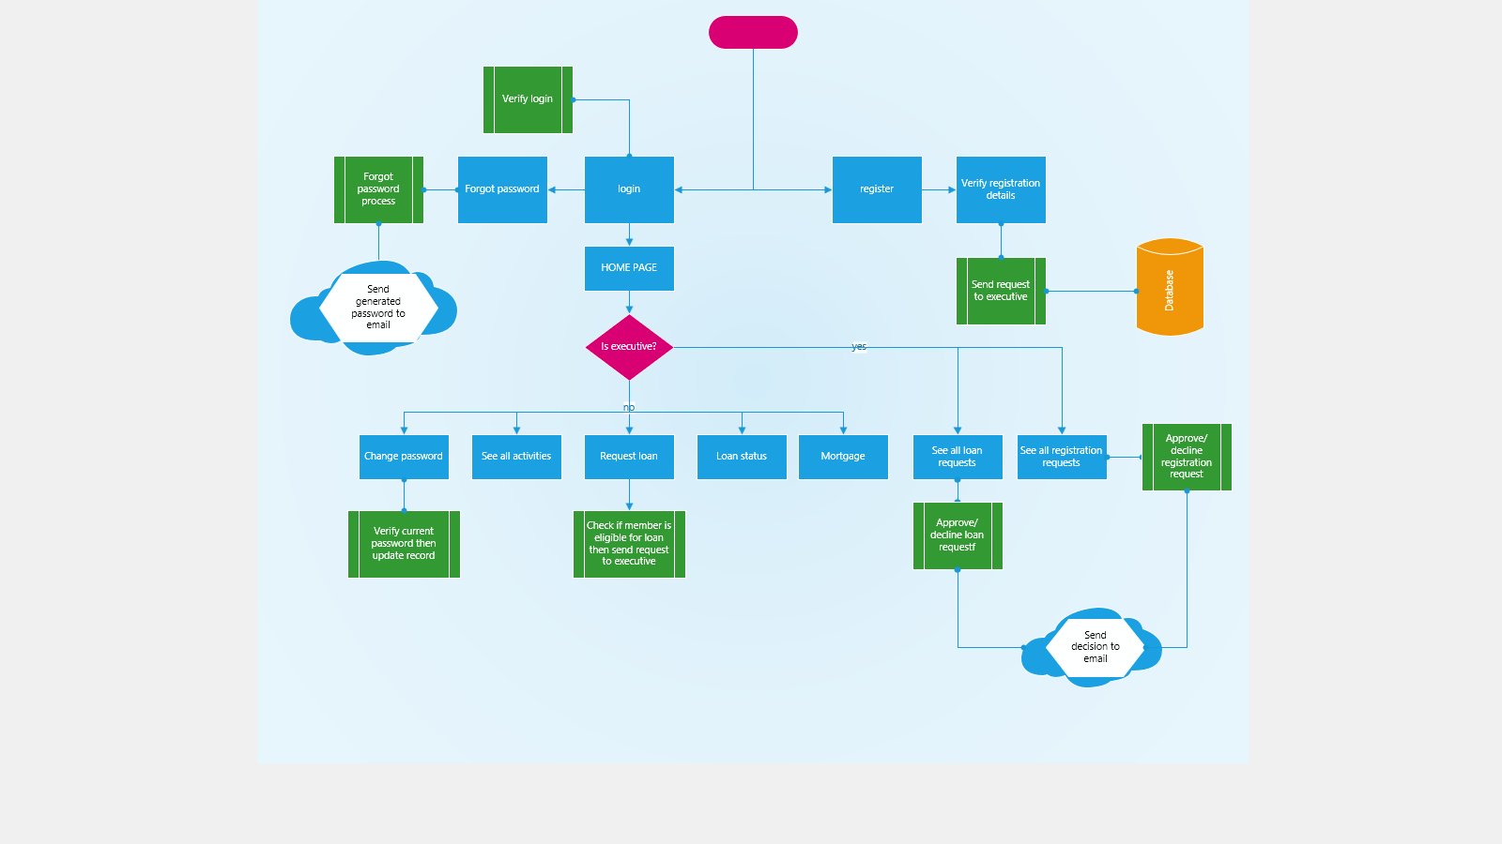

**Figure 3.1- Application Diagram for mobile application**



**Figure 3.2- Application Diagram for web application**

### **3.6.2 Use case diagram**

From figure 3.3, that the actor labeled ‘executive’ is also a member but can perform an extra set of functions that other members cannot perform.

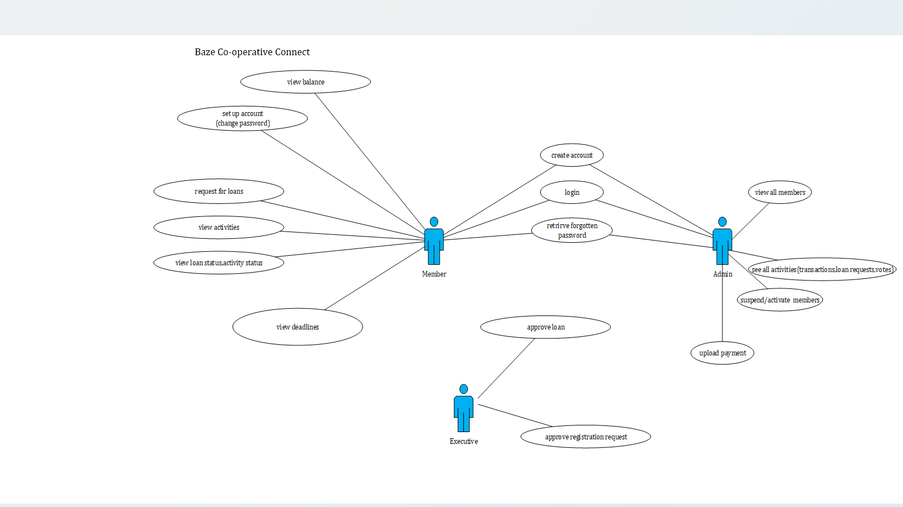

**Figure 3.3- Use case diagram for members and admin**

**Table 3.6 - Use case description for loan Request**

|  |  |  |
| --- | --- | --- |
| Use case | Request loan | |
| Description: | Entails the loan request process performed by members | |
| Actor | Member | |
| Preconditions | Member is logged in  Member has at least 5000 in savings  Member has paid part of their active loan | |
| Post Conditions | Confirmation message or failure message is displayed | |
| Main flow | **User**  1) user selects loan requests  2) user enters loan details  3) user submits form | **System**  4) system checks if the user balance is above 5000.  5)system checks if other conditions are met to request for a loan.  6)system either displays confirmation message and sends a request to the executive, or it displays a failure message. |
| Exception condition | No details entered in the form or invalid characters entered. | |

**Table 3.8.2 - Use case description for View Loan Status**

|  |  |  |
| --- | --- | --- |
| Use case | View loan status | |
| Description: | Description of a member viewing their loan status | |
| Actor | Member | |
| Preconditions | Member is logged in | |
| Post Conditions | Details of active loan displayed | |
| Main flow | **User**  1) user selects loan status | **System**  2) system searches the active loans collection for loans with the staff-id  3)system displays all results |
| Exception condition | No details entered in the form or invalid characters entered. | |

**Table 3.8.3 - Use case description for uploading payments**

|  |  |  |
| --- | --- | --- |
| Use case | Uploading payments | |
| Description: | Description of the use case for the admin uploading a member’s payment | |
| Actor | Admin | |
| Preconditions | Admin is logged in  Staff-id is valid | |
| Post Conditions | Savings or loan balance of Staff will be updated | |
| Main flow | **User**  1) Admin selects upload payments  2) Admin enters staff id and paid amount | **System**  3) system searches the database for if the member has a loan or not  4) If there is a loan, the loan balance is updated, else the savings balance is updated |
| Exception condition | Staff ID doesn’t exist | |

**Table 3.8.4 - Use case description for registration approvals**

|  |  |  |
| --- | --- | --- |
| Use case | Registration approvals | |
| Description: | Description of the registration approval/rejection of members | |
| Actor | Executive member | |
| Preconditions | Executive member is logged in | |
| Post Conditions | Registration of member is either approved or declined | |
| Main flow | **User**  1) Executive member selects registration Requests  2) member selects either approve or decline | **System**  2) system finds registration request, if approved, create a new member account.  3)send email to member |
| Exception condition | Member email is incorrect | |

### **3.6.3 Entity-Relationship Diagram (ERD)**

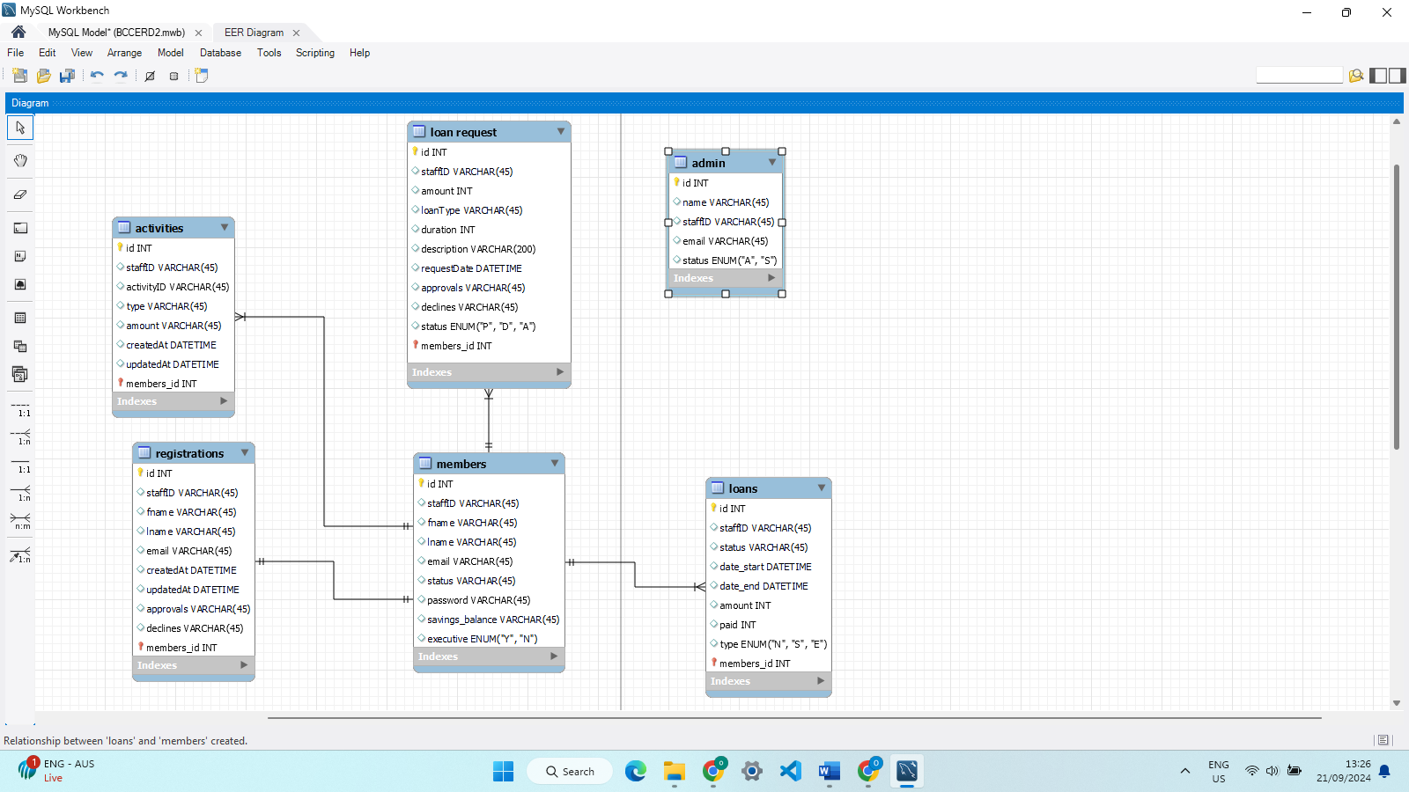

**Figure 3.4 ERD diagram**

### **3.6.4 Data Dictionary**

**Table 3.6 Data Dictionary for Member Table**

|  |  |  |  |  |
| --- | --- | --- | --- | --- |
| **Column** | **Type** | **Range** | **Required** | **PK/FK** |
| staffId | INTEGER | 45 | Y | PK |
| fname | VARCHAR | 45 | Y | - |
| lname | VARCHAR | 45 | Y | - |
| email | VARCHAR | 45 | Y | - |
| status | ENUM(‘S’,’A’,’E’) | - | Y | - |
| password | VARCHAR | 45 | Y | - |
| savings_balance | INTEGER | - | Y | - |
| phone_number | VARCHAR | 45 | Y | - |

For the ‘status’ attribute, its type is an ENUM which is short for enumeration and allows you to the specify certain values that the column can take as values. Here there is the ENUM ‘S’,’A’,’E’. where-

1. ‘S’- signifies that a member has been suspended.
2. ‘A’- signifies that a member is active.
3. ‘E’- signifies that a member is now an EX-member.

NOTE: This set of values will be used in the structure of other tables.

**Table 3.7 Structure of data collected for Admin.**

This table collects relevant data on the Admins of the Co-operative.

|  |  |  |  |  |
| --- | --- | --- | --- | --- |
| **Column** | **Type** | **Range** | **Required** | **PK/FK** |
| staffId | INTEGER | 45 | Y | PK, FK |
| email | VARCHAR | 45 | Y | - |
| status | ENUM(’A’,’T’) | - | Y | - |
| password | VARCHAR | 45 | Y | - |

The ENUM with values ‘A’,’T’ is described as-

‘A’- the admin is currently active in the co-operative.

‘T’- the admin has been terminated.

**Table 3.8 Structure of data collected for Loan.**

|  |  |  |  |  |
| --- | --- | --- | --- | --- |
| **Column** | **Type** | **Range** | **Required** | **PK/FK** |
| id | INTEGER | - | Y | PK |
| amount | INTEGER | - | Y | - |
| status | ENUM(‘A’,’C’) | - | Y | - |
| paid | INTEGER | - | Y | - |
| date_start | DATETIME | - | Y | - |
| staffID | INTEGER | - | Y | FK |
| duration | INTEGER | - | Y | - |
| Date_end | DATETIME | - | Y | - |

the attribute “status” has type ENUM(‘A’,’C’) where-

1. ‘A’- means active, meaning that a loan is active (it has been approved and has not been paid off).
2. ‘C’- means completed, meaning that a loan is completed (it has been fully paid off).

**Table 3.9 Structure of data collected for activities.**

|  |  |  |  |  |
| --- | --- | --- | --- | --- |
| **Column** | **Type** | **Range** | **Required** | **PK/FK** |
| activity_id | INTEGER | - | Y | PK, |
| date | DATETIME | - | Y | - |
| staffId | INTEGER | - | Y | FK |
| type | ENUM(‘A’,’L’,’R’,’P’) | - | Y | - |
| amount | INTEGER | - | Y | - |

the attribute “type” has type ENUM(‘T’,’L’,’R’,’V’) where-

1. L- means loan request.
2. R- means registration.
3. P- means password changed.
4. A- means

**Table 3.10 Structure of data collected for loan Requests.**

|  |  |  |  |  |
| --- | --- | --- | --- | --- |
| **Column** | **Type** | **Range** | **Required** | **PK/FK** |
| activity_id | INTEGER | - | Y | PK, FK |
| amount | VARCHAR | 45 | Y | - |
| status | ENUM(‘A’,’D’,’P’) | - | Y | - |
| description | VARCHAR | 45 | Y | - |
| date_end | DATETIME | - | Y | - |
| staffId | INTEGER | - | Y | FK |
| loanRequestcol | INTEGER | - | Y | - |
| duration | INTEGER | - | Y | - |
| approvals | INTEGER | - | Y | - |
| type | ENUM(‘N’,’E’) | - | Y | - |

For the “status” column, it takes values ‘A’,’D’,’P’ where-

1. ‘A’- means that the loan has been approved.
2. ‘D’- means that the loan has been declined.
3. ‘P’- means that the loan is pending.

The “type” column shows what kind of loan is being requested either ‘N’,’E’ which represent “Normal” and “Emergency”.

**Table 3.11 Structure of data collected for registration Requests.**

|  |  |  |  |  |
| --- | --- | --- | --- | --- |
| **Column** | **Type** | **Range** | **Required** | **PK/FK** |
| activity_id | INTEGER | - | Y | PK, FK |
| staffID | INTEGER | - | Y | FK |
| Date_end | DATETIME | - | Y | - |
| approvals | ARRAY | - | Y | - |
| declines | ARRAY | - | N | - |
| status | ENUM(‘D’,’P’,’A’) | - | Y | - |

For the “status” column, it takes values ‘A’,’D’,’P’ where-

1. ‘A’- means that the members registration has been approved.
2. ‘D’- means that the members registration has been declined.
3. ‘P’- means that the members registration is pending.

### **3.6.5 Activity Diagrams**



**Figure 3.5 - activity diagram for a member’s login.**



**Figure 3.6- activity diagram detailing the registration process of a user.**



**Figure 3.7 activity diagram detailing the loan request process by members.**



**Figure 3.8 activity diagram detailing the changing of passwords by users.**

### **3.8.5 Data Flow Diagram**

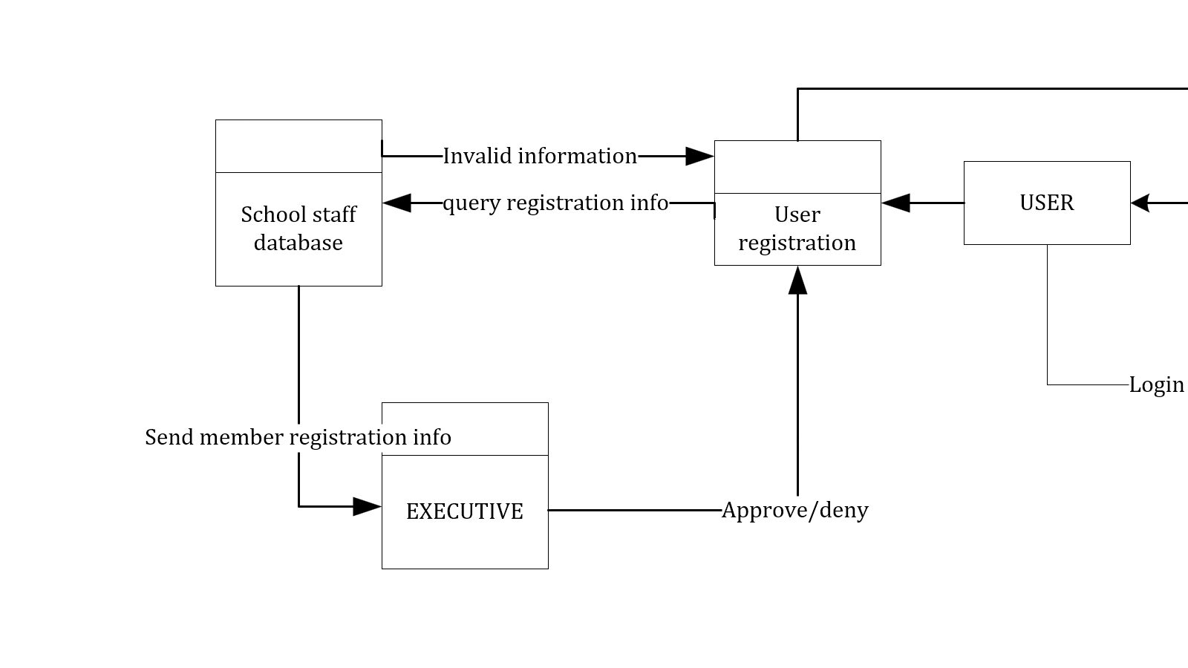

**Figure 3.9- data flow diagram for user registration**

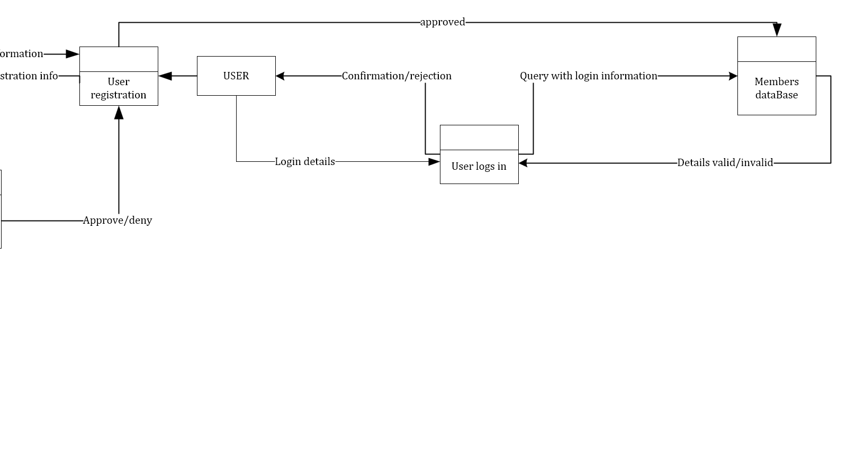

**Figure 3.10 – data flow diagram for user login**



**Figure 3.11- data flow diagram for loan request process**

### **3.6.6 Control Flow Diagram**

The control diagram should depict how certain actions alter the application’s flow of execution.

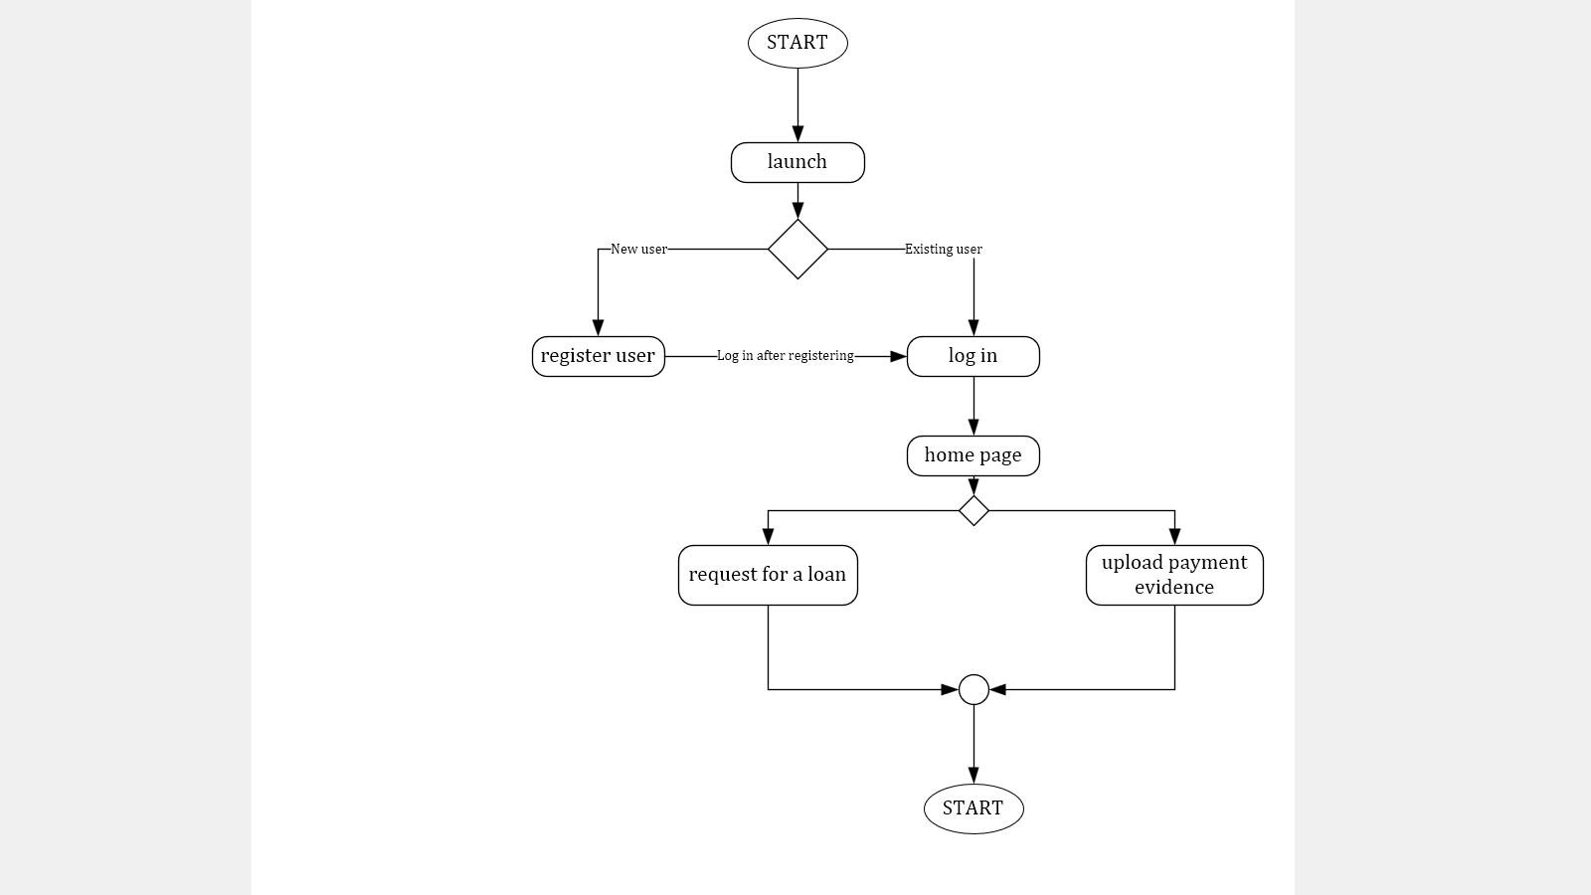

**Figure 3.12- the figure below shows the control flow diagram.**

### **3.6.7 User Interface Design**



**Figure 3.13 mobile application loading page below.**

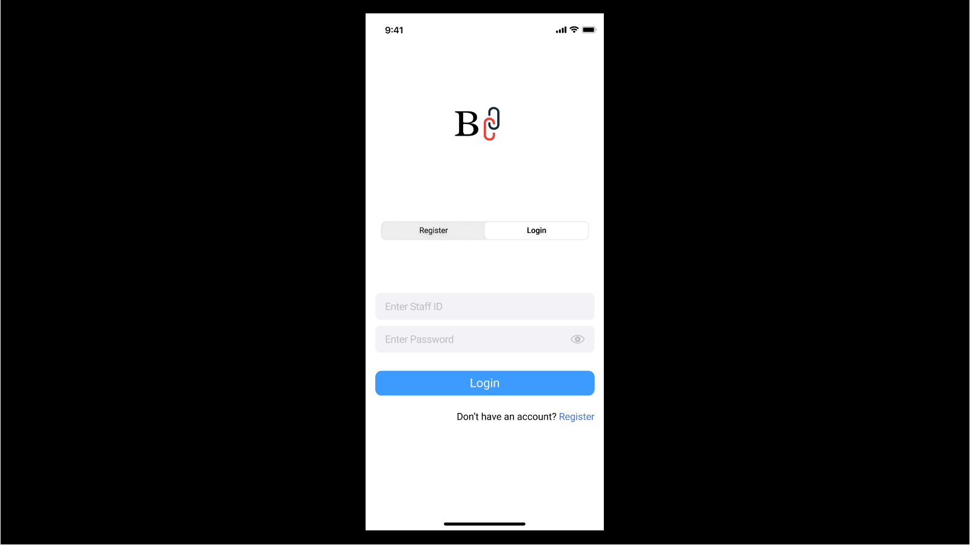

**Figure 3.14 mobile application log-in page.**

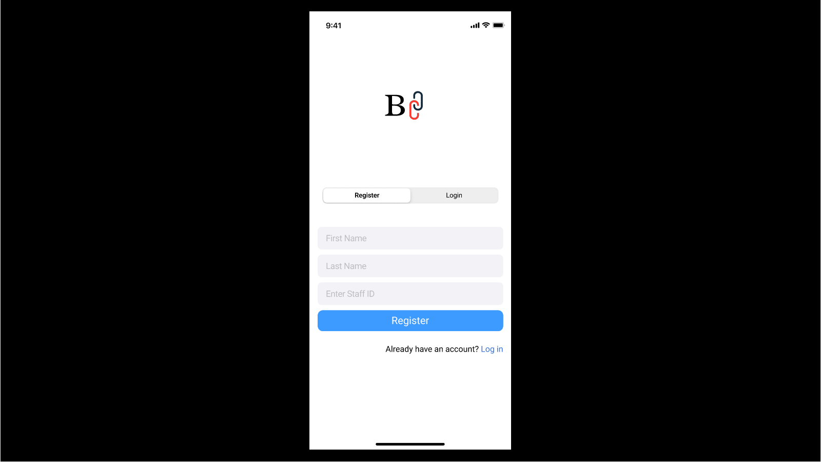

**Figure 3.15 mobile application registration page.**

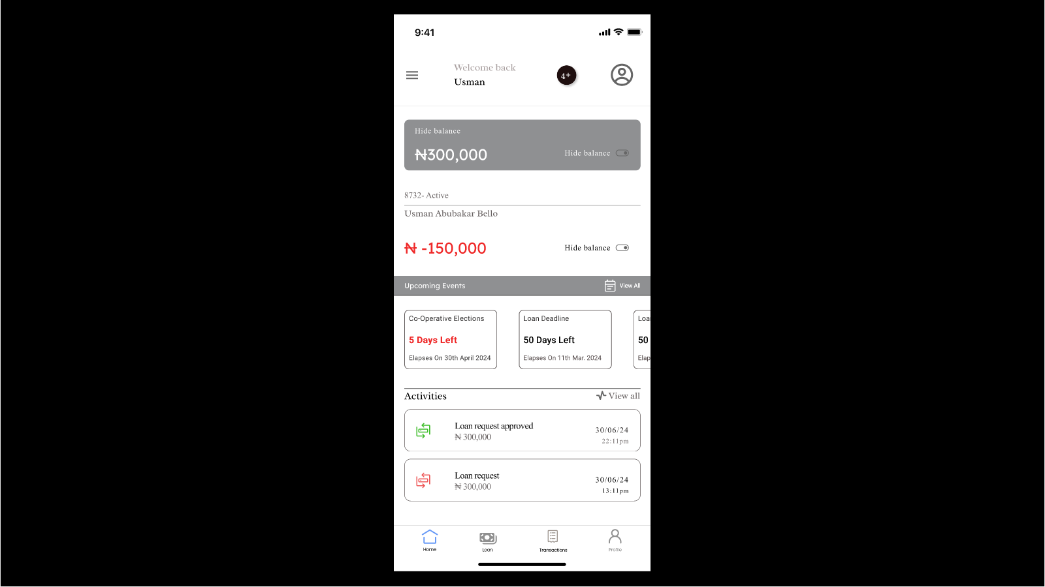

**Figure 3.16 mobile application dashboard page.**

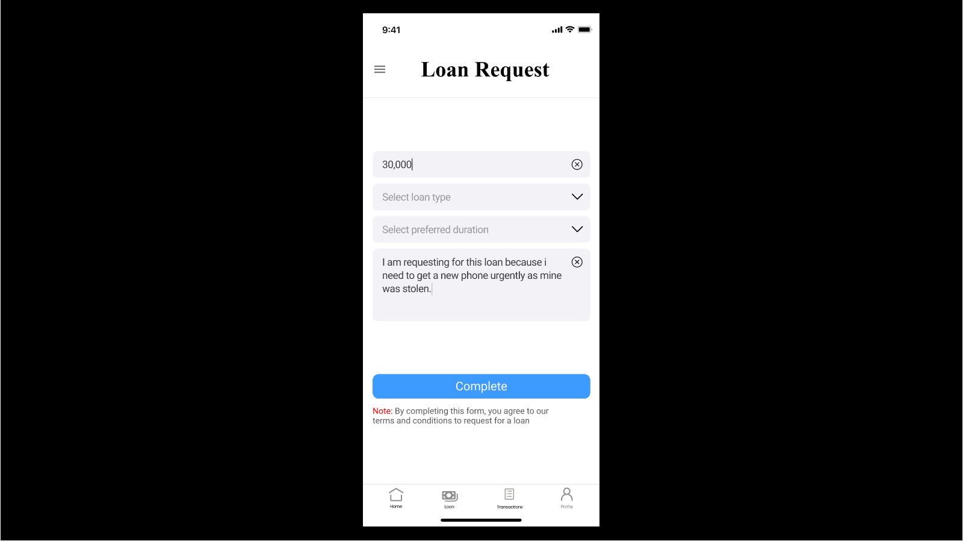

**Figure 3.17 mobile application Loan Request page.**

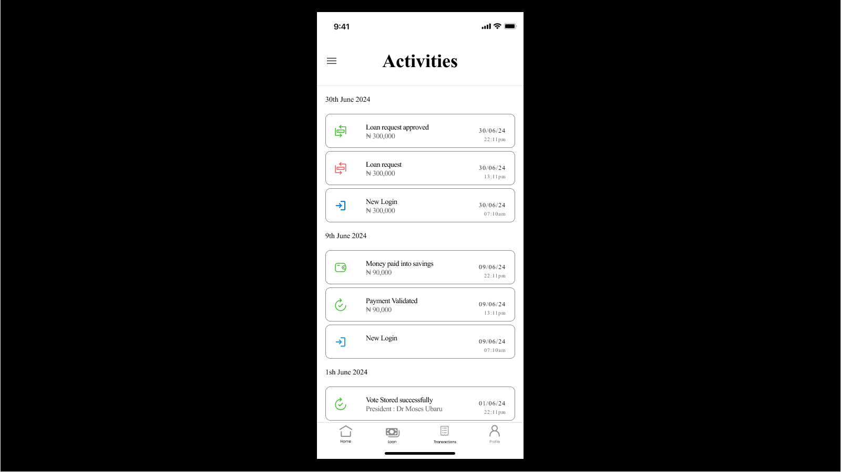

**Figure 3.18 mobile application Activities page.**

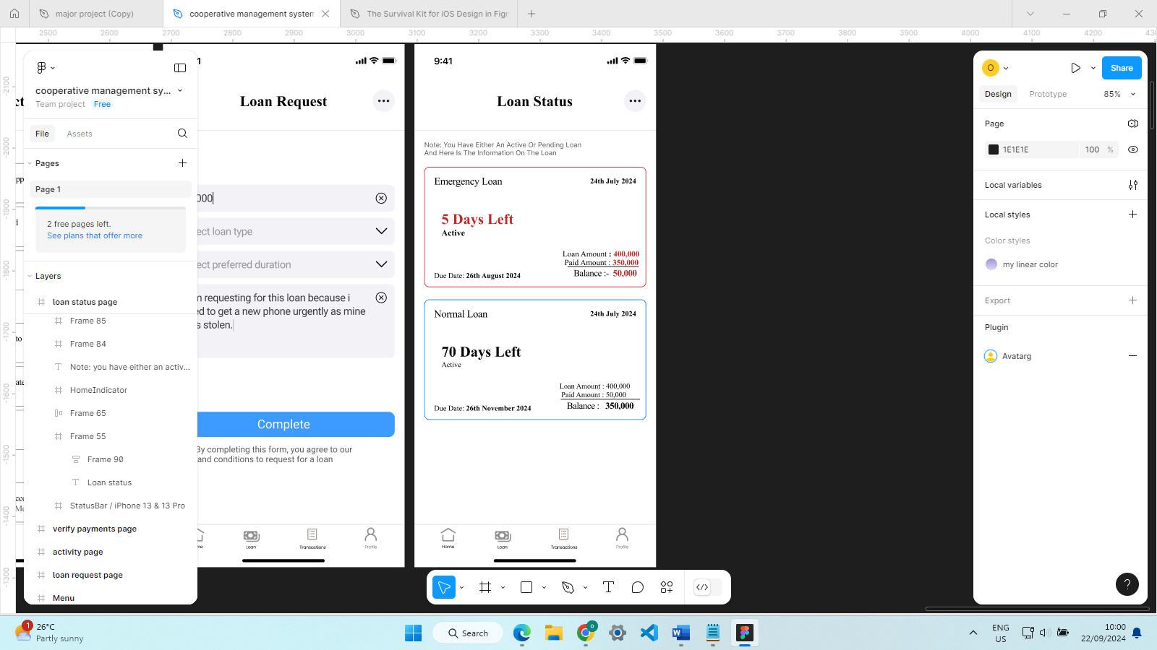

**Figure 3.19 mobile application loan Status page.**

# Chapter 4

# Testing and Implementation

## 4.1 Overview

This chapter covers the development of the system as well as other relevant aspects that have helped with the development like the database, frontend and backend. As well as difficulties faced throughout the development process and how they were solved.

## 4.2 Main Features

The main features of the system are-

1) **AUTHENTICATION**: the backend server contains logic that allows us to authenticate users on the system. New members may sign up on the Register page that is shown in **figure 4.1** below so that the registration data will be stored in the database.

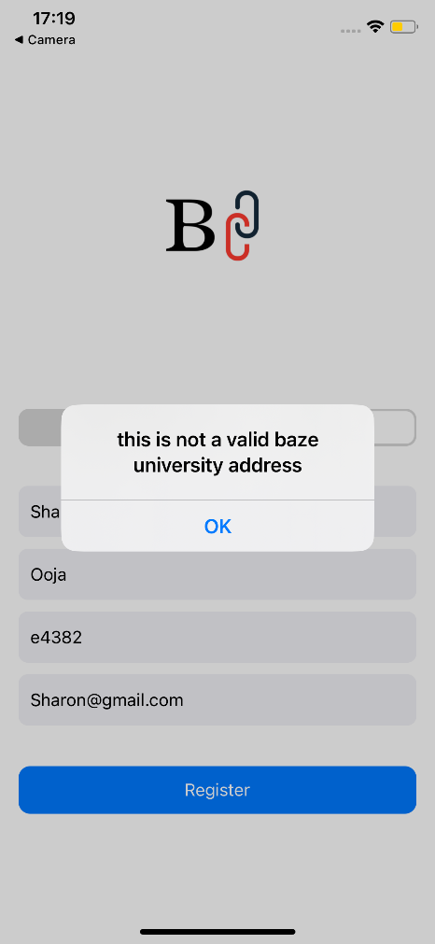

**Figure 4.1 invalid registration** **depicting a user trying to register with an email that isn’t provided by Baze university**.

Since only the staff of Baze university are allowed to be a part of the cooperative, the registration form will filter out registration requests that don’t have the valid format for Baze university’s staff ID or requests that without the Baze university email.

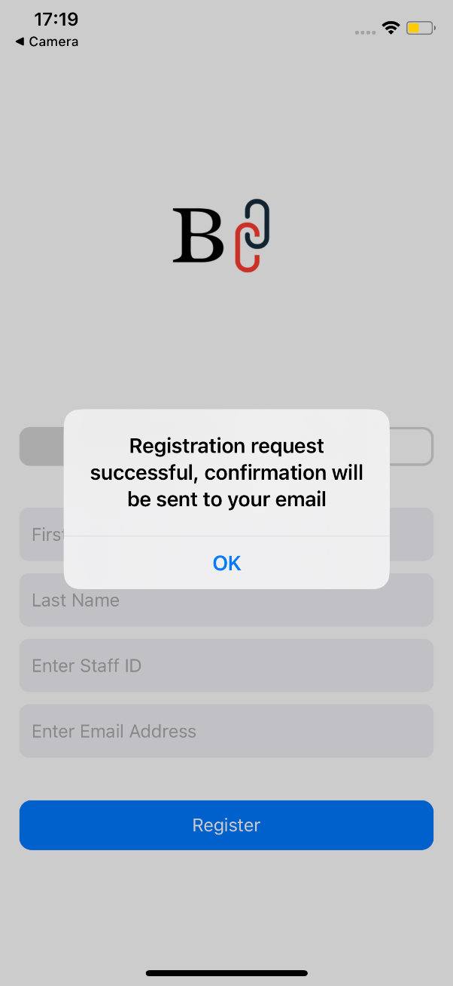

**Figure 4.2 showing successful registration**

If the provided information has been verified, then it will be stored in the database under the “registrations” collection shown in figure 4.3. with the staff-ID and email address acting as the primary keys

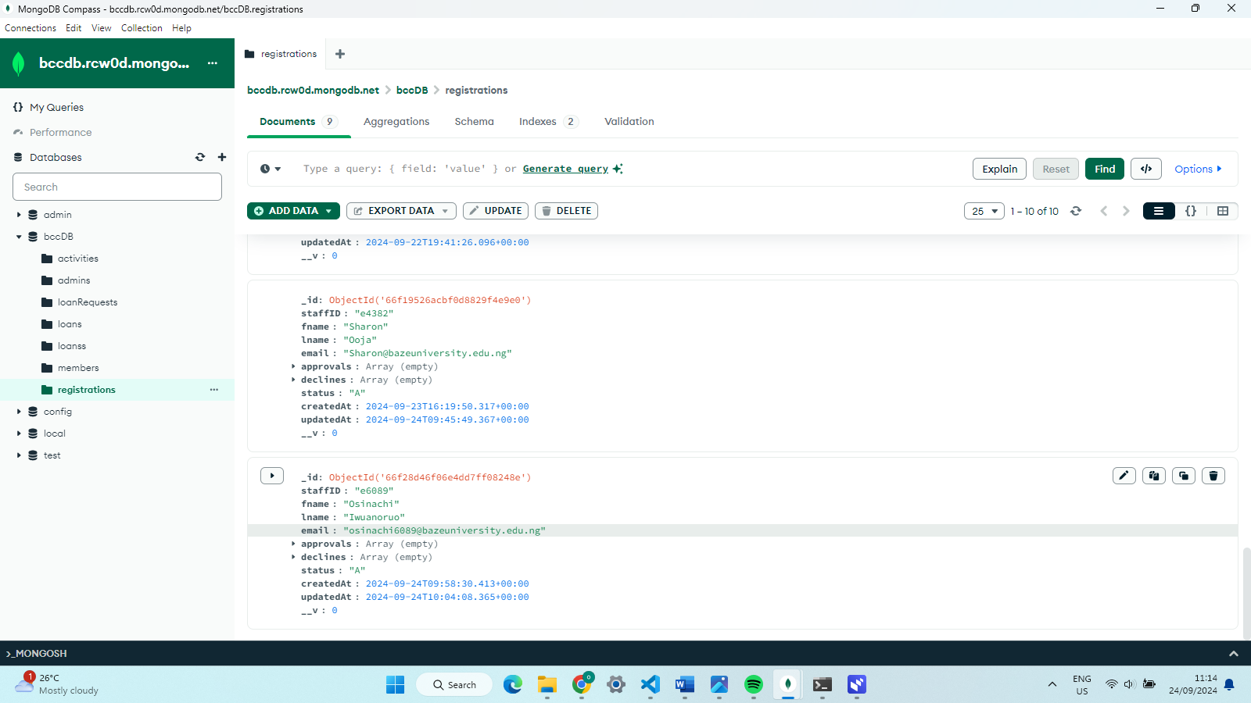

**Figure 4.3 Member registrations Collection**

The above figure shows how a user’s registration is stored in the database to be shown to the executive for the executive’s rejection or rejection.

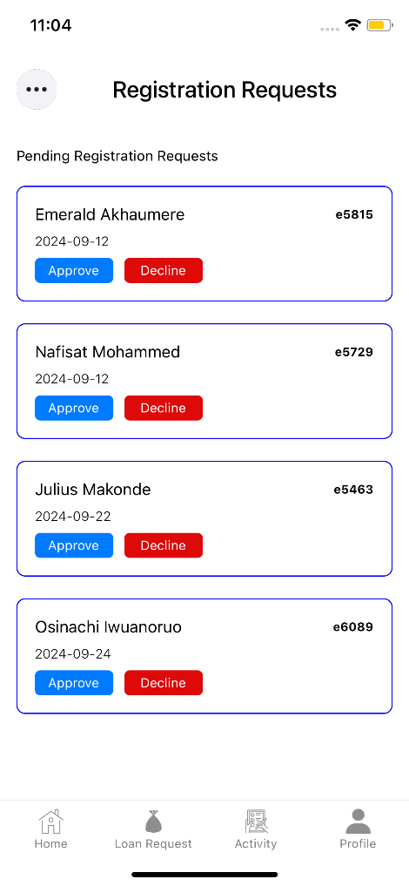

**Figure 4.4 registration requests page**

Shows the executives view for registration requests, where the last request is the most recent request made.

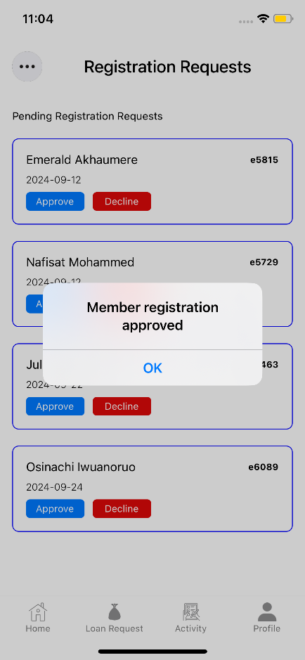

**Figure 4.5 registration approved**

The figure above shows the confirmation message that the user’s registration has been approved, and then an email containing the default password should be sent to the appropriate member. A rejection email will also be sent in the case of an executive rejecting the request.

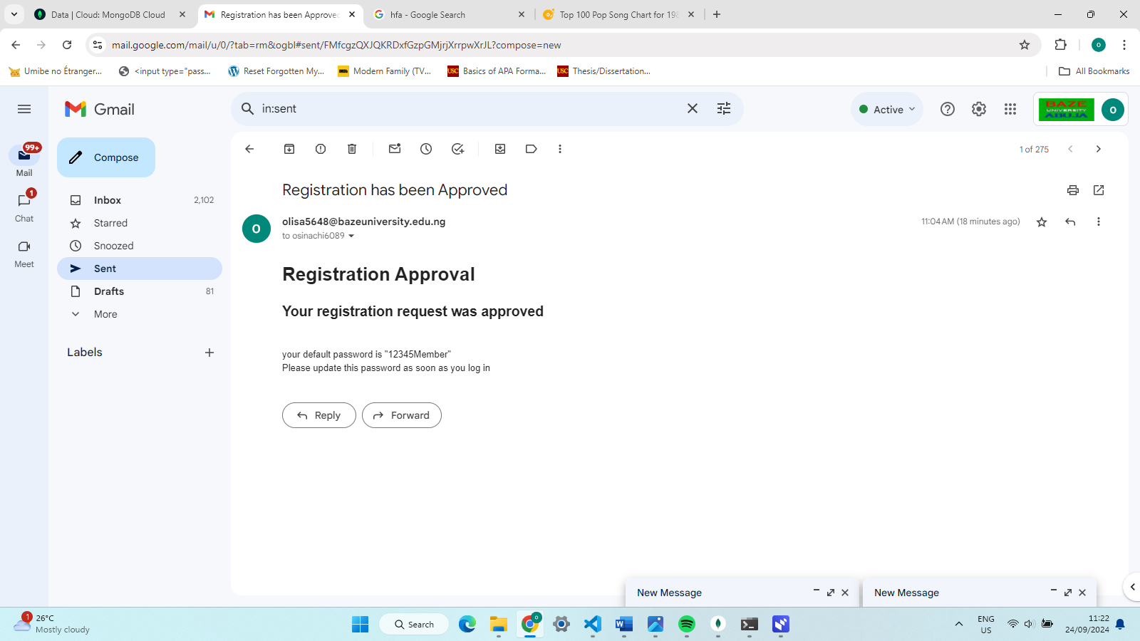

**Figure 4.6 Approval sent to member**

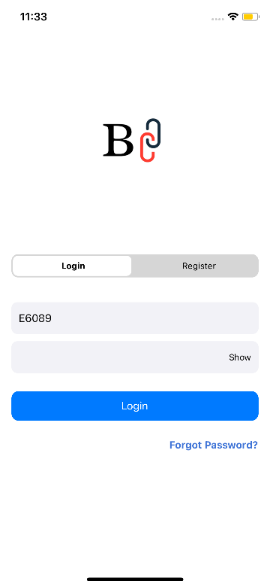

**Figure 4.7 New member login**

The recently approved member can now login on the system (**Note**: password does not appear in screenshot because of secure text feature). If the entered details don’t match a record in the database, or the entered details don’t match a specified pattern, the system will not accept it and show an “invalid details” alert.

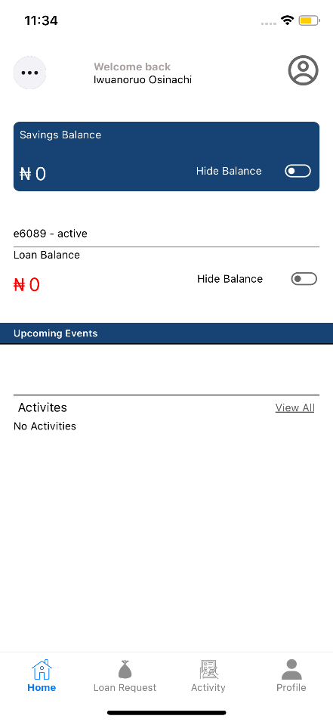

**Figure 4.8 new member homepage**

Above, we can see the homepage of a member who has recently had their account approved. They cannot perform financial activities until they have a certain amount in their savings.

3) **loan Request:** the new member has no balance until the admin from the web app updates their balance, the figure below depicts the admin updating the new member’s balance.

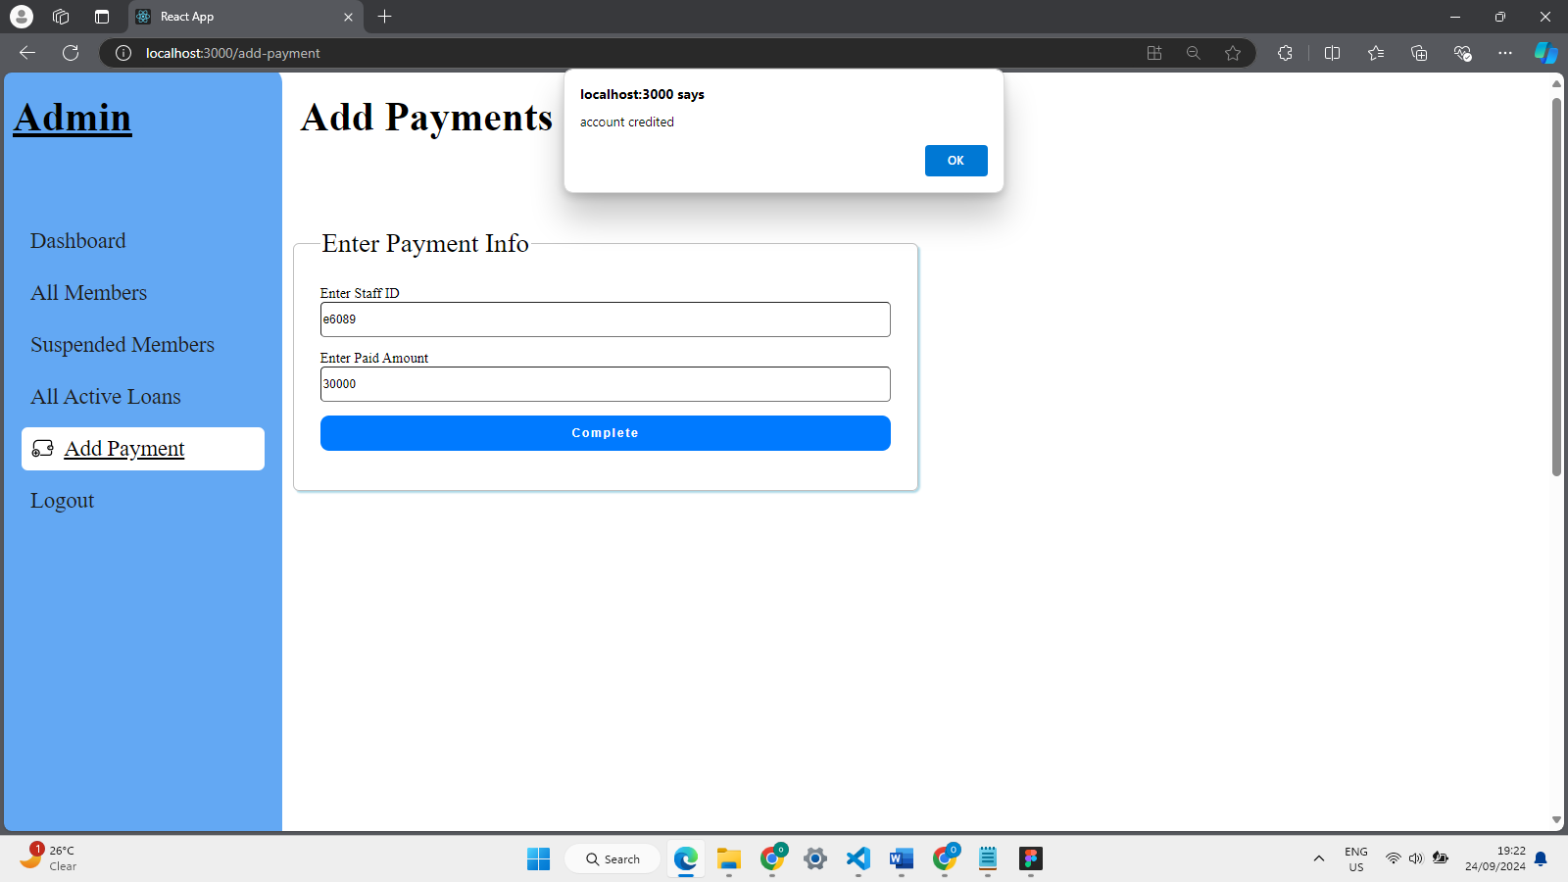

**Figure 4.9 admin adding members payment**

In the figure above, the admin has successfully added an amount to the members account, the system will check if the current staff has an active loan, if they do then the money is sent towards their loan. Else it will be sent towards their savings. In the database, we should see the member’s savings balance updated since they don’t have an active loan.

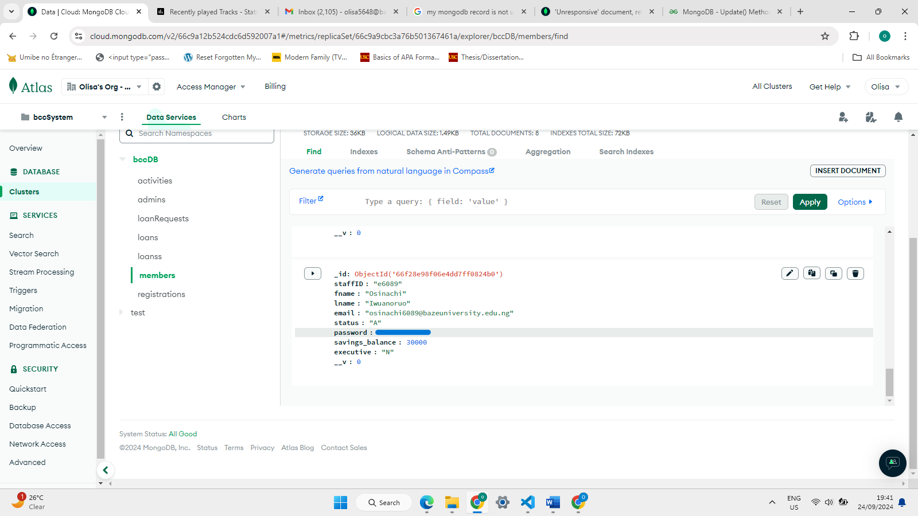

**Figure 4.10 The savings balance has been updated**

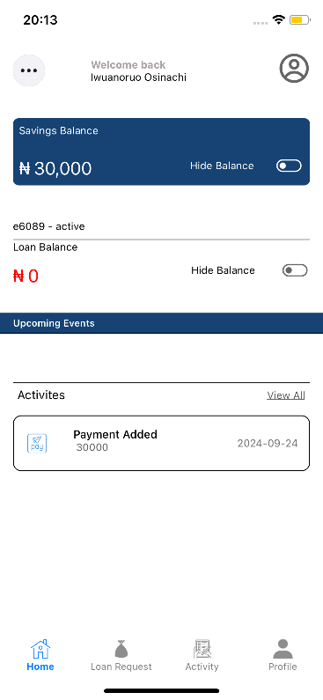

**Figure 4.11 Members View**

Now the member is eligible to request for a loan, below is the loan request page. It should be noted that the recent payment that was made has been added under the recent activities section and a list of all activities can be found under the “Activities” page.

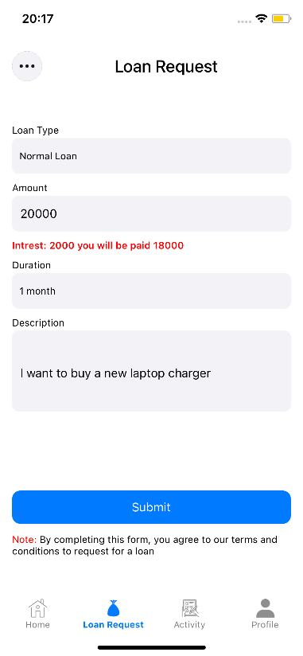

**Figure 4.12 Loan Request**

For the different kinds of loans, there are different criteria’s to be met to be eligible for the loan. The system will consider the members savings balance to know how much they can request for, if they have any pending loans and how much they have paid towards it, if the duration for the selected loan type is within the predefines maximum limit. If these criteria are met, then the request is sent to the executive for approval or rejection.

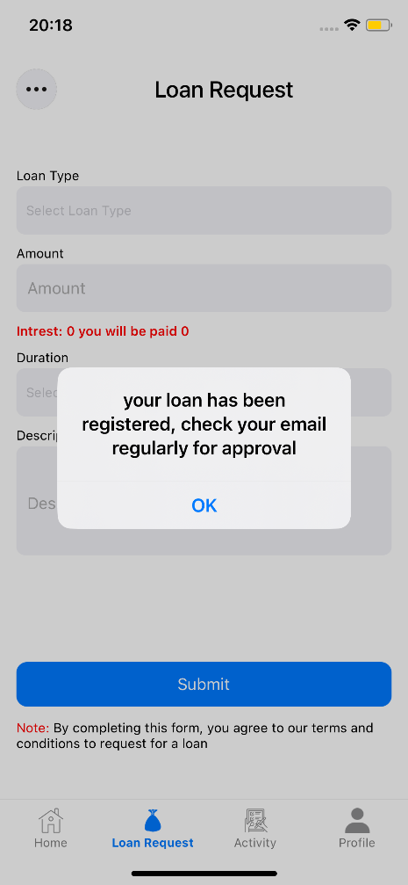

**Figure 4.13 loan approval alert**

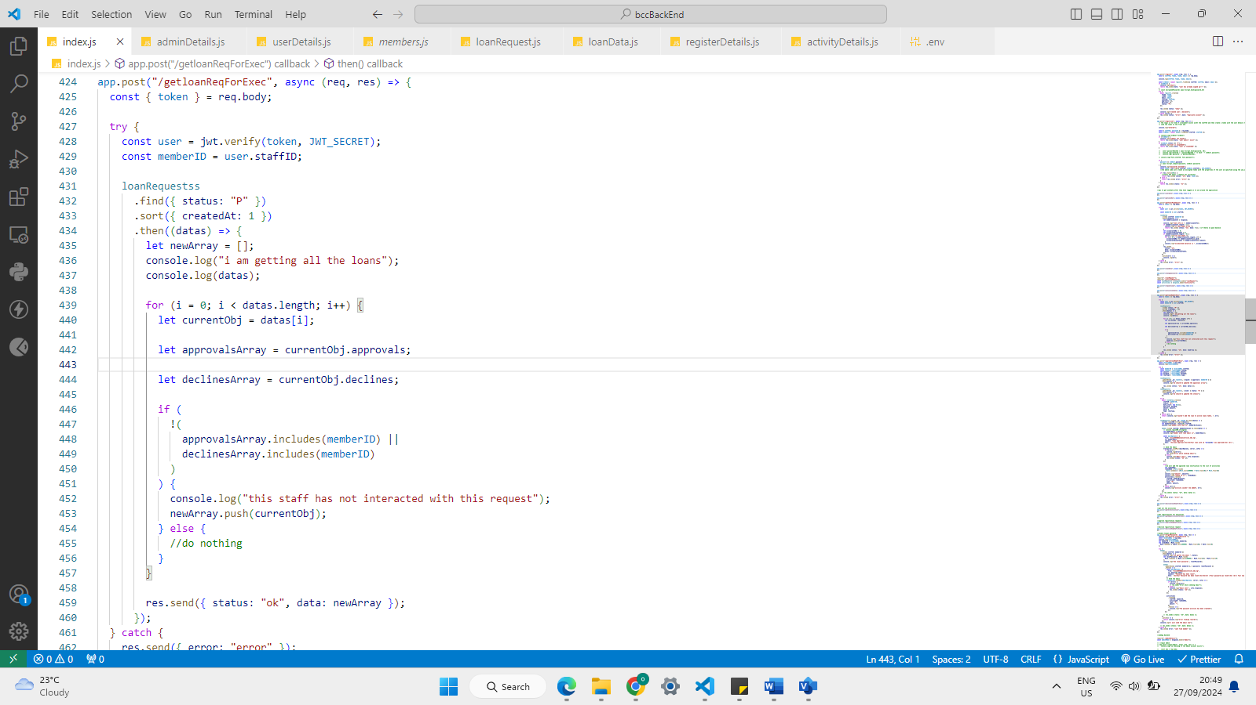

The above figure shows the logic for showing loan requests to the executive. Firstly, all pending loan requests are gotten from the database, then for each record, it is checked if the staff-id of the executive is found under the approvals, or declines array because if it does, then the staff has already either approved or declined the registration request before and should not be shown the request again,

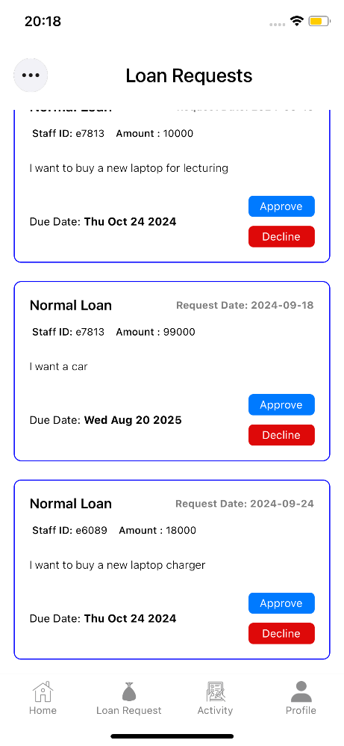

**Figure 4.14 Executive view for loan requests**

The last loan request on the page is the most recent one and the executive can either decline or approve. If they decline, they are shown a prompt to give a reason, and this reason is sent along with the rejection email to the address of the designated member. If the loan has been approved, then the changes will be reflected on the members dashboard.

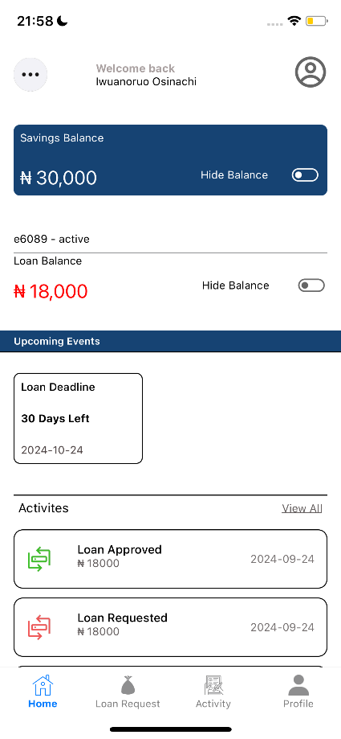

**Figure 4.15 Updated dashboard**

now that the loan has been approved, we can see the changes with the loan balance being updated, the loan deadline appearing under the events section and the activity appearing under the activities section. More information on the loan will be found in the loan status page.

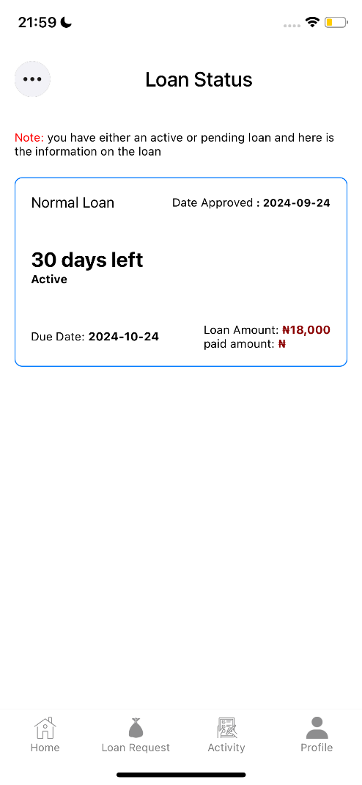

**Figure 4.16 Loan Status page**

In the figure above, for the active loan, we can see the loan type, how many days till the deadline, the approved date and the actual due date, the loan amount and how much has been paid towards the loan.

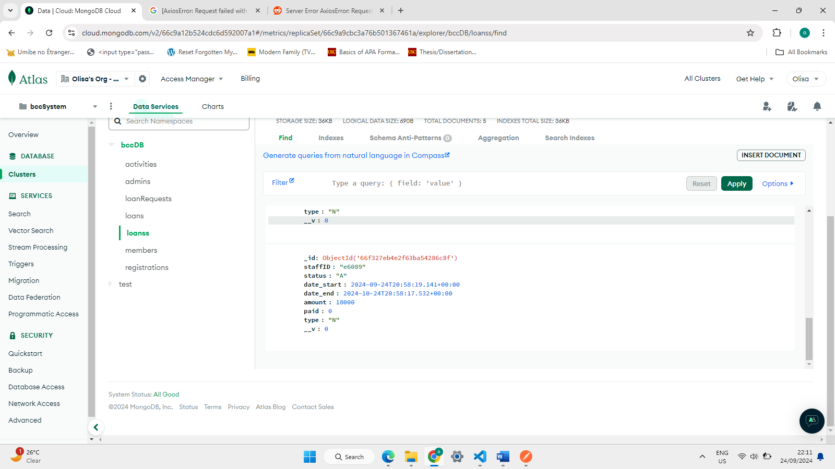

**Figure 4.17 loan stored in database**

The figure 4.17 above shows how data on active loans are represented in the database.

**Admin Web App**

Some features of the Administrators app have been outlined below-

**1) LOGIN/ LOGOUT:** the admin must provide details that match a record in the database.

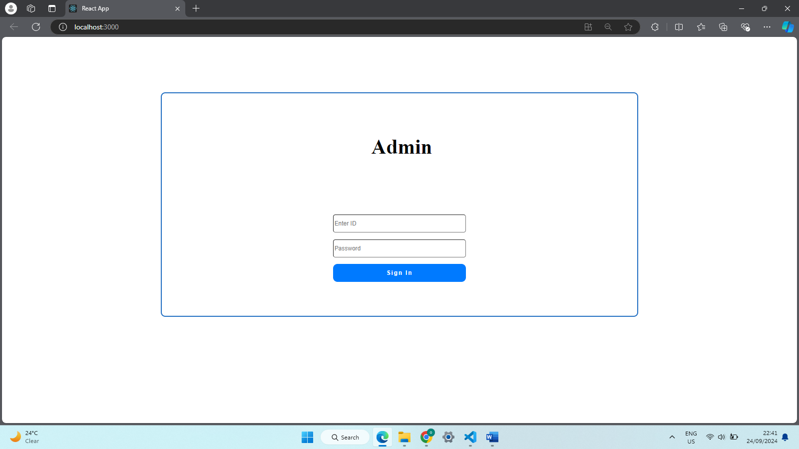

**Figure 4.18 Admin login page**

**2) DASHBOARD:** the admin sees how many total members there are, how many are suspended, and the total active loan amounts

**3) SEE ALL MEMBERS:** on the active members page, the admin finds all active members and may quickly suspend a previously active member. The member details provided are the name, staff-id, status, email. When the admin clicks the suspend button, they get a confirm alert to ensure that the button wasn’t clicked accidentally, if confirmed, a suspension email is sent to the member and their activity status is updated.

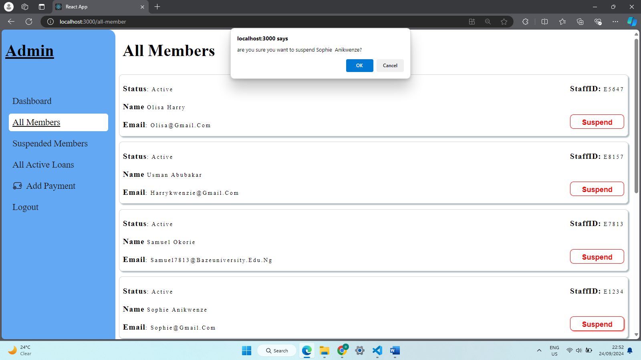

**Figure 4.19 All member’s page**

**4) ACTIVATE A MEMBER:**  the admin can also activate a suspended members account from the suspended members’ page.

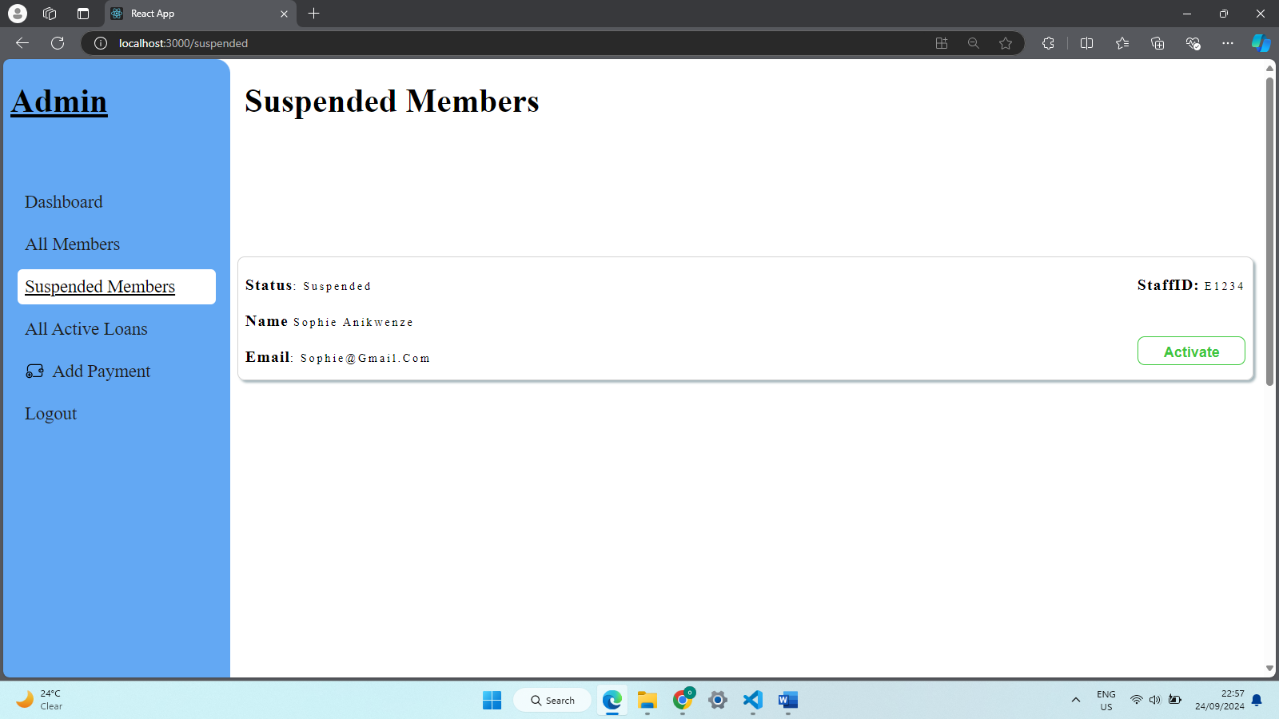

**Figure 4.20 All suspended page**

This page displays all the suspended members of the co-operative, clicking the activate button will show a confirm alert to reduce human error. The member details provided are the name, staff-id, status, email.

**5) VIEW ACTIVE LOANS:**  all active loans may be viewed by the admin, and they can see who has the active loan, how much has been allocated and how much has been paid back.

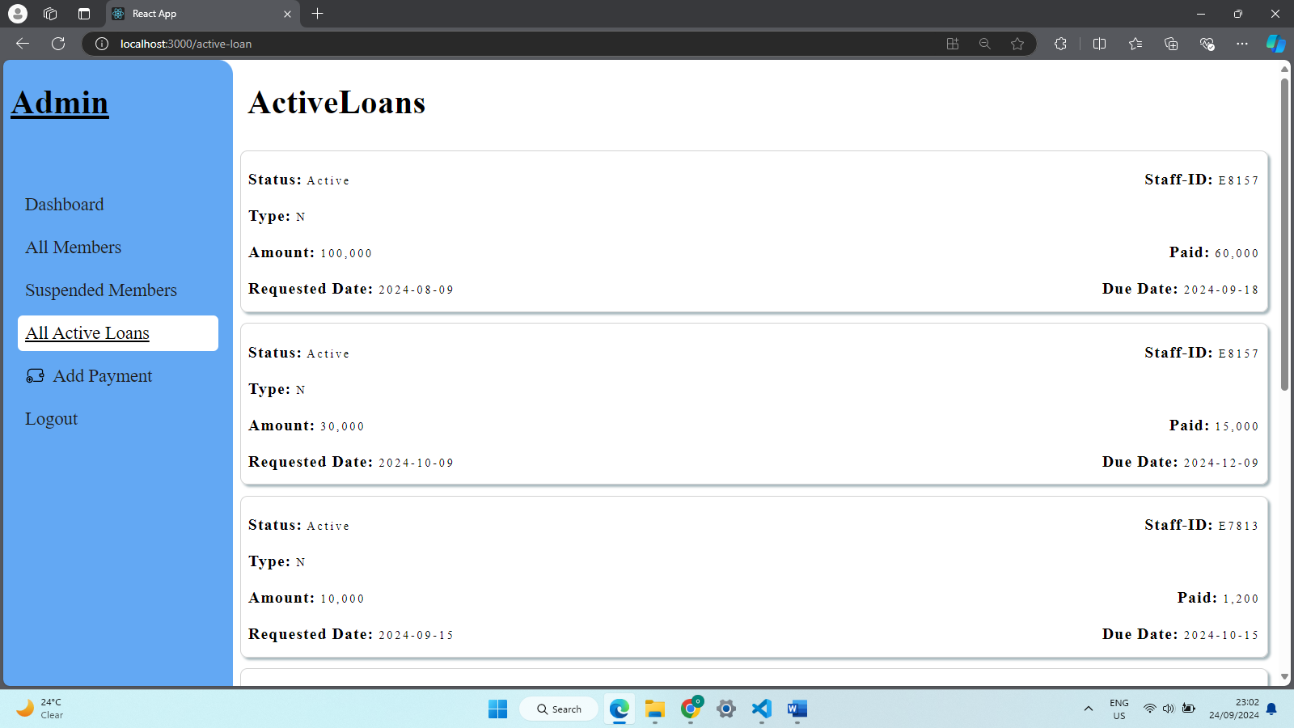

**Figure 4.21 All Loans page**

**6) UPDATE PAYMENT:** once the admin has confirmed a member’s payment, they can update their account’s balance on the “Add Payments” page. They don’t need to bother about if it’s towards the loan or savings. The system will check If there is an active loan for the member and if there is, then the amount will go towards it, else it will go towards their savings.

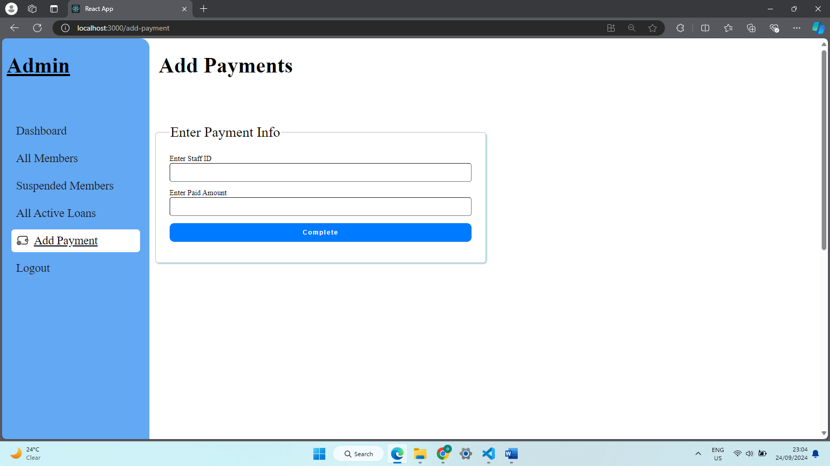

**Figure 4.22 Add Payments page**

## **4.3 Implementation Problems**

Throughout the course of the systems development, there were a few hitches in the development that were solved with proper problem-solving skills, some have been outlined below-

1. **Learning a new language-** learning new technologies like React Native, Nodejs, MongoDB was quite challenging as the timeframe to learn all of them and implement the knowledge was quite small, but I was able to properly implement these different technologies to develop a set of apps that communicate with each other by God’s Grace.
2. **React Native version-** the Latest React native version changes the file organization, and it was difficult to find documents and tutorials that were up to date.
3. **Relatively slow data retrieval-** as there are no servers in the country, the time taken to retrieve data from the cloud was with noticeable lag, but I was able to connect to a server within closer range.
4. Since I did not have access to the institutions database and neither am I a staff member, I had to build my own mock database on the information I was able to gather and perform some reasonable and logical assumptions.
5. There have not been a great number of active applications for co-operative societies to review.

## **4.4 Overcoming Implementation Problems**

the problems mentioned above were overcome by performing extensive research on the related areas.

1. Watching several video tutorials and reading official documentations offered on the technologies made development easier.
2. Making sense of the new file structure made building the application speedy.
3. Interviews with members of the co-operative society helped me to understand their workings and clear some assumptions.

## **4.5 Testing**

To ensure that the system worked properly and met the required specifications, the systems were tested from the point of view of the end users to depict how the systems perform in a real-world use case, to show if the applications can perform proper error handling, or if they are even usable at all. Testing methods such as unit testing, were used to analyze the systems from the frontend to the backend.

### **4.5.1 Test Plans (for Unit, Integration and System Testing)**

**Table 4.1 Test Summary for user registration**

|  |  |
| --- | --- |
| Test Case | User Registration |
| Related requirements | R-5 |
| Prerequisites | User should be able to access the main login/register page |
| Test procedures | Click on the “Register” toggle button  Enter valid signup details  Click on “Register” button |
| Test Data | Users Valid details |
| Expected Results | Registration sent to executive |
| Actual Result | Registration information was sent to executives view |
| Status | Pass |
| Remarks | None |
| Created by | Anikwenze Olisa Harry |
| Date of creation | 23rd August 2024 |
| Executed by | Anikwenze olisa Harry |
| Date of execution | 23rd August 2024 |
| Test environment | Hp laptop |

**Table 4.2 user login testing**

|  |  |
| --- | --- |
| Test Case | User login |
| Related requirements | R-4 |
| Prerequisites | User should be able to access the main login/register page, member account must be active |
| Test procedures | Click on the “login” toggle button  Enter valid staff-id and password  Click on “login” button |
| Test Data | Valid staff id and password |
| Expected Results | Member should be taken to the home page where they can see their loan and savings balance |
| Status | Pass |
| Remarks | None |
| Created by | Anikwenze Olisa Harry |
| Date of creation | 23rd August 2024 |
| Executed by | Anikwenze olisa Harry |
| Date of execution | 23rd August 2024 |
| Test environment | Hp laptop |

**Table 4.3 user loan request**

|  |  |
| --- | --- |
| Test Case | User loan request |
| Related requirements | R-3 |
| Prerequisites | Member is logged in  Member has paid over half of their current loans  Member has an active account |
| Test procedures | Navigate to loan requests page  Select loan type  Enter loan amount and select duration  Optionally enter reason for loan request |
| Test Data | Amount must be a number, duration must correlate with loan type, |
| Expected Results | Loan request should be stored in database and shown to the executive |
| Status | Pass |
| Remarks | None |
| Created by | Anikwenze Olisa Harry |
| Date of creation | 23rd August 2024 |
| Executed by | Anikwenze olisa Harry |
| Date of execution | 23rd August 2024 |
| Test environment | Hp laptop |

**Table 4.4 Executive loan approval/rejection**

|  |  |
| --- | --- |
| Test Case | Executive loan approval/rejection |
| Related requirements | R-101 |
| Prerequisites | Member is logged in  Member is an executive |
| Test procedures | Navigate to loan requests page on executive drop-down menu  Click either the approve or decline button  Optionally give a reason for rejection if the decline button is clicked |
| Test Data | Loan request and staff id |
| Expected Results | Loan request should either be approved or declined and a confirmation or rejection email should be sent to the members email |
| Status | Pass |
| Remarks | None |
| Created by | Anikwenze Olisa Harry |
| Date of creation | 23rd August 2024 |
| Executed by | Anikwenze olisa Harry |
| Date of execution | 23rd August 2024 |
| Test environment | Hp laptop |

**Table 4.5 Executive registration approval/rejection**

|  |  |
| --- | --- |
| Test Case | Executive registration approval/rejection |
| Related requirements | R-102 |
| Prerequisites | Member is logged in  Member is an executive |
| Test procedures | Navigate to registration requests page on executive drop-down menu  Click either the approve or decline button |
| Test Data | Registration request, clicked button and staff id |
| Expected Results | Registration request should either be approved or declined and a confirmation or rejection email should be sent to the members email |
| Status | Pass |
| Remarks | None |
| Created by | Anikwenze Olisa Harry |
| Date of creation | 23rd August 2024 |
| Executed by | Anikwenze olisa Harry |
| Date of execution | 23rd August 2024 |
| Test environment | Hp laptop |

**Table 4.6 user see loan status**

|  |  |
| --- | --- |
| Test Case | Member views loan status |
| Related requirements | R-2 |
| Prerequisites | Member is logged in  Member has an active loan |
| Test procedures | Navigate to loan status page on drop-down menu  View all active loans |
| Test Data | Staff ID |
| Expected Results | Any active loans for the member should be shown on this page |
| Status | Pass |
| Remarks | None |
| Created by | Anikwenze Olisa Harry |
| Date of creation | 23rd August 2024 |
| Executed by | Anikwenze olisa Harry |
| Date of execution | 23rd August 2024 |
| Test environment | Hp laptop |

**Table 4.7 Admin suspends or activates a member account**

|  |  |
| --- | --- |
| Test Case | Admin activated/suspends user account |
| Related requirements | R-202 |
| Prerequisites | Admin is logged in |
| Test procedures | Navigate to either all Members page or suspended members page  Select the activate/suspend button  Select okay from the confirmation alert |
| Test Data | Staff id and selected button |
| Expected Results | The members account should either be suspended or activated and an appropriate email should be sent to the email of the member |
| Status | Pass |
| Remarks | None |
| Created by | Anikwenze Olisa Harry |
| Date of creation | 23rd August 2024 |
| Executed by | Anikwenze olisa Harry |
| Date of execution | 26th August 2024 |
| Test environment | Hp laptop |

## **4.6 Use Guide**

**Step1: Internet connectivity**

Make sure your device has a stable internet connection.

**Step2: Registration or Login**

1. New members should be full in the registration form with valid registration details and check their emails regularly for confirmation with password or rejection emails.
2. Returning users should fill in the login form with valid login details to gain access to the system.
3. The admin should login on the web app with their valid login information.

**Step3: Homepage/Dashboard**

**For all members (Executive Inclusive)**

1. Click the three dots at the top left corner to get to mortgage, see your loan status or log out.
2. Click the hide icon to hide either loan or savings balance.
3. Click on the activities link to see all activities.

**For Executives only (Regular members exclusive)**

1. Click the three dots at the top left corner to get to see all loan requests and registration requests.

**Step4: Loan request page**

**For members with at least 5000 in savings**

1. Fill the loan request form with valid details
2. Check interest before filling out the form
3. Click the “submit” button to send form to executive

**Step:5 All activities**

1. Click “Activities” from the navigation bar to see all activities performed on the account
2. Scroll to see older activities sorted by date

**Step6: Profile page**

1. See your account related information
2. Click “Change password” to change your password

**Step7: Loan status page**

See all active loans sorted in order of the lowest days remaining

**FOR EXECUTIVE ONLY**

**Step9: Loan requests page**

1. Click approve to approve a member’s loan request
2. Click decline to reject a member’s loan request and optionally give a reason

**Step10: registration requests page**

1. Click approve to approve a member’s registration request.
2. Click decline to reject a member’s registration request.

**FOR ADMIN ONLY**

**Step11: ADD payment**

1. Select add payment to add member payment
2. Enter valid staff-ID and amount then click update

**Step12: suspend member**

1. Select all members’ link
2. Click the suspend button and select “ok” from the prompt to suspend member’s account

**Step13: activate member**

1. Select suspend members’ link
2. Click the activate button and select “ok” from the prompt to activate member’s account

## **4.7 Summary**

The testing of a system is very important to the final version that will be rolled out to the public. Various kinds and stages of testing must be carried out to find out if the system is usable or meets the needs of the end-user. Proper testing was carried out on this system and any errors found were rectified accordingly. The next chapter covers an assessment of the project, the summary and any recommendations for future iterations.

# **CHAPTER 5**

# **DISCUSSION, CONCLUSION, AND RECOMMENDATIONS**

## **5.1 Overview**

The content of this chapter evaluates the project, including the constraints faced during development and any features that will be incorporated to enhance its functionality in the future.

## **5.2 Objective Assessment**

Most of the objectives set for the system were completed like allowing members of the co-operative to request for loans on a digital platform, keep track of their loan and savings balance, see all their activities, approve and decline requests quickly allowing members to use their free time more productively. As advancements in technology continue, the system will also be updated to not lack.

## **5.3 Limitations and Challenges**

Developing the systems proved to be a greatly demanding task to accomplish and I was able to acquire necessary skills to see it through. Some challenges have been outlined below:

1. **Time management**: managing my time between demanding schoolwork, house chores and developing both a mobile and web application required I fine tune my time management skills to deliver a properly working app.
2. **New Technologies:** getting to understand these new technologies was not easy as I was not familiar with them before.

For members to access the applications’ features, they must meet the following requirements,

1. A member should have internet connection to login or register.
2. A member should have internet connection to request for a loan, see all activities, change their password.
3. An executive must have internet connection to see loan/ registration requests and to approve or decline them.
4. An admin must have internet connection to suspend or to activate a members account.
5. An admin must have internet connection to update a member’s balance.

## **5.4 Future Enhancements**

With the given period for the project to be completed, some features were not incorporated, these features include:

1. **Voting system**: the members of the co-operative can vote for members during an election.
2. **Upload payments**: members can upload payment evidence for the executives to validate directly.
3. **Link system to school’s bank records**

## **5.5 Recommendations**

Some measures that can be followed to enhance the usability of the system include:

1. Set a reminder for payment of loans
2. Use an anti-virus on mobile phone or any device

## **5.6 Summary**

## This chapter concludes the project documentation. This document contains all phases of the software development process including the aims and objectives, the challenges and limitations faced and overcome, assessment of possible risks and how they may be mitigates, requirement analysis, project design and implementation and the methodology that guided the development process. Adequate testing was carried out to ensure that the systems were reliable and efficient. Finally, recommendations and suggestions for future improvements were analyzed.

### **REFERENCES**

Andreansyah, A., & Rizkiana, R. (2020). “Implementation of Incremental Models on Development of Web Based Loan Cooperative Applications”. International Journal of Education, Science, Technology and Engineering, 3(1),26-34, <https://doi.org/10.36079/lamintang.ijeste-0301.105>

Atanasova, A., Eckhardt, G., & Laamanen, M. (2024). Platform cooperatives in the sharing economy: How market challengers bring change from the margins.

Budzinski, M. (2024). What Is React Native? Complex Guide for 2024. NetGuru. <https://www.netguru.com/glossary/react-native>

Carrell, S. (2007). Strike Rochdale from the record books. The Co-op began in Scotland. The Guardian. <https://www.theguardian.com/business/2007/aug/07/retail.uknews>

Deshpande, C. (2024). The Best Guide to Know What Is React. Simplilearn. <https://www.simplilearn.com/tutorials/reactjs-tutorial/what-is-reactjs#:~:text=Easy%20creation%20of%20dynamic%20applications,thereby%20creating%20web%20applications%20faster>.

Domantas, G. (2023). What Is CSS and How Does It Work? Hostinger. https://www.hostinger.com/tutorials/what-is-css

Gillis, A., & Botelho, B. (2023). What is MongoDB. TechTarget. <https://www.techtarget.com/searchdatamanagement/definition/MongoDB>

Goray, S. (2024). History of Mobile Apps - The Past, Present and Future. Webandcrafts. [The History of Mobile Apps and Evolution of Mobile Platforms (webandcrafts.com)](https://webandcrafts.com/blog/history-of-mobile-apps)

Gillis, S. (2023). What is MongoDB? TechTarget. <https://www.techtarget.com/searchdatamanagement/definition/MongoDB> [Accessed on 29/05/2024]

Howart, J. (2024). How Many People Own Smartphones? Exploding Topics. <https://explodingtopics.com/blog/smartphone-stats>

Mbam, E., & Igboji, O (2013). Enhancing Cooperative Loan Scheme through Automated Loan Management System, West African Journal of Industrial & Academic Research,6(1), 144-152

Moechammad, S., Devi-Khanthi, B., Putri-Elfa, M., Yunia, M., Nailul, Muna5., & Ekananda, S (2021). “Bulletin of Electrical Engineering and Informatics”:The development and implementation of an android-based saving and loan cooperative application. 10(6), 3482-3488

Muller, S., & Tworek, H. (2015). ‘The telegraph and the bank’: on the interdependence of global communications and capitalism. Cambridge University Press. <https://www.cambridge.org/core/journals/journal-of-global-history/article/abs/telegraph-and-the-bank-on-the-interdependence-of-global-communications-and-capitalism-18661914/09E91AB90AE1274717589316F28B6E73>

National Library of Scotland. (2023). The history of working people in Scotland. <https://www.nls.uk/learning-zone/politics-and-society/labour-history/>

Olorunlomerue, A., Ekuewa, B., Oyetunji, O., & Ramoni, A. (2017). Web Based Centralized Cooperative Information Management System. International Journal of Computer Trends and Technology (IJCTT). 54(2), 126-129.

Oluyombo, O (2013). Impact of Cooperative Societies Savings Scheme in Rural Finance: Some Evidence from Nigeria. Economic Review -Journal of Economics and Business,11(1):77-88

Onyeama, C., Ekeh, E., Onyike, G., & Onwubuariri, I (2017). Design and Implementation of a Web Based Saving Scheme Management System, IRJN Journal of Management, 2(1): 1-21

Saini, A. (2024). MongoDB – Working and Features. GeeksforGeeks. <https://www.geeksforgeeks.org/what-is-mongodb-working-and-features/>

Seffusatti, N. (2024). “No Man Is an Island”: The Power of Community. GUIDE COLLECTIVE. <https://www.guide-collective.com/gc-magazine/no-man-is-an-island-the-power-of-community> . [Accessed on 30/06/2024]

Semah, B. (2022). What Exactly is Node.js? Explained for Beginners. freeCodeCamp. <https://www.freecodecamp.org/news/what-is-node-js/>

Sobolev, A., Bednyagin, S., & Yurmanova, H. (2023). Cooperative Platforms: The Practice of Digital Participation. Springer Link. [Cooperative Platforms: The Practice of Digital Participation | SpringerLink](https://link.springer.com/chapter/10.1007/978-3-031-29364-1_76)

Sumana, G. (2023). 7 Leading Software Development Methodologies. DESIGNRUSH. <https://www.designrush.com/agency/software-development/trends/software-development-methodologies> .

Wegner, D., Borba, A., & Mitrega, M. (2024). A systematic review of collaborative digital platforms: structuring the domain and research agenda. 4(18), 2663-2695.

Wright, G., & Ferguson, K. (2024). Application architecture. Techtarget. <https://www.techtarget.com/searchapparchitecture/definition/application-architecture> [Accessed on 29/05/2024]

Yusuff, A., Folajin. O., & Oriowo. O (2020). Appraisal of Information and Communication Technology in Cooperative Societies Management: A Case Study of Cooperative Societies in Osun State Tertiary Institution of Learning, Nigeria. The International Journal of Business & Management,3(4):438

# **Appendix A - Project Document**

**IN-DEPTH PROJECT DOCUMENTATION**

**Full Candidate Name**: Anikwenze Olisa Harry

**Student ID**: BU/21C/IT/5648

**Title** Design and Implementation of a Co-operative System for Baze University Staff.

**Course of Study**: B.Sc. Computer Science [Software Engineering].

## **Background and Motivation**

The current state of the Nigerian economy has become almost unbearable for Nigerians with the price of food, fuel amongst other necessities skyrocketing beyond all reasonable levels. The need for properly functioning co-operative societies has never been so dire in the country.

With the existing cooperative society in Baze University, the staff already carry out these executives, but more manual based which takes significant time from their daily lives that could be spent towards more productive tasks. The development of a digital platform will greatly impact the society and increase their efficiency and accuracy while saving them time.

This system will greatly lessen the burden carried by the society’s executive team in the case of validating registration or even approving loans; and even those levied upon its members like in the case of requesting for loans.

## **Statement of the Problem**

The activities carried out by the members of Baze University is manual based and must be digitalized to match current trends and increase efficiency.

There the issue of some requests made by members not being attended to, so the system follows a FCFS approach to displaying requests on the system.

# **Appendix B – Interview**

There was multiple interview sessions conducted with a member of the Baze Co-operative. Some questions asked were-

Me: what Exactly does Baze cooperative Need?

Answer: the members must always know their balances.

 Me: what balance?

Answer: their loan balance, savings balance, how much they have left to pay, and Its due date.

Me: how does the current system work?

Answer: the current system follows works on an FCFS (first come first Serve) basis, because members have the issue of not being attended to, So the proposed system should follow that principle.

Me: what are some of the problems faced by the co-operative members?

Answer: → Newcomers may be attended to first before others

→ there is no way for the members to know their balance

Me: what are some of the problems faced by the co-operative executive?

Answer:

→ the debtors find it hard to pay back, making the creditors struggle to gather these funds.

→ keep track of all members, (current members, Ex-members, Suspended members)

→ the executive panel should be given real time notifications about activities on the app that is the activities that are necessary for them to know of.

Me: Is it open to only Academic Staff?

Answer: Not just academic staff, but non-teaching staff only at Baze university also.

Me: Will the System allow members to make in App payments?

Answer: while not a core function, it will be a fine feature

Me: is registration done in person?

Answer → that is the set up in place, where you go to someone maybe in an office, then upon Some sort of review they are added to the cooperative.

Me: Can a member request for multiple loans at once?

Answer: No, but in a special Condition, yes. If for a member’s current active loans, they have paid at least 55% of their balance, then they Can request for a new loan.

Me: will a mobile application or web application be better for the society?

Answer: a mobile application can be developed for the members of the co-operative to perform their activities while a web-based application can be used by the admin to oversee activities of the co-operative.

# Appendix C- Source Codes

**Loan request page**

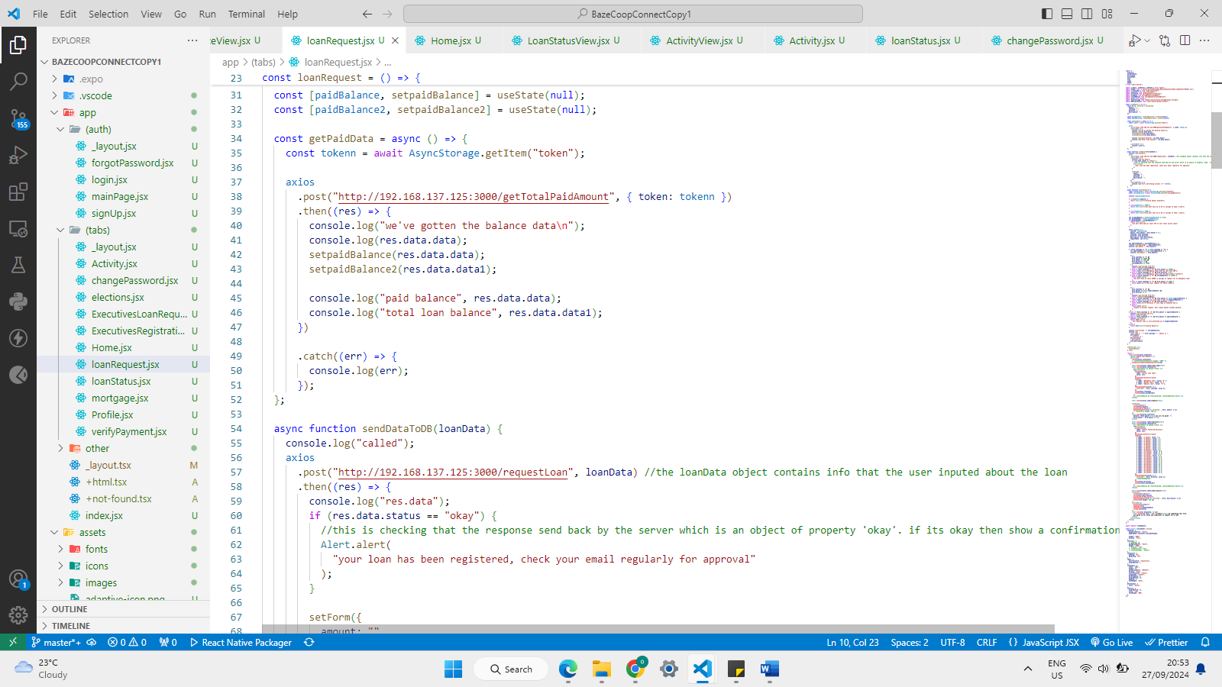

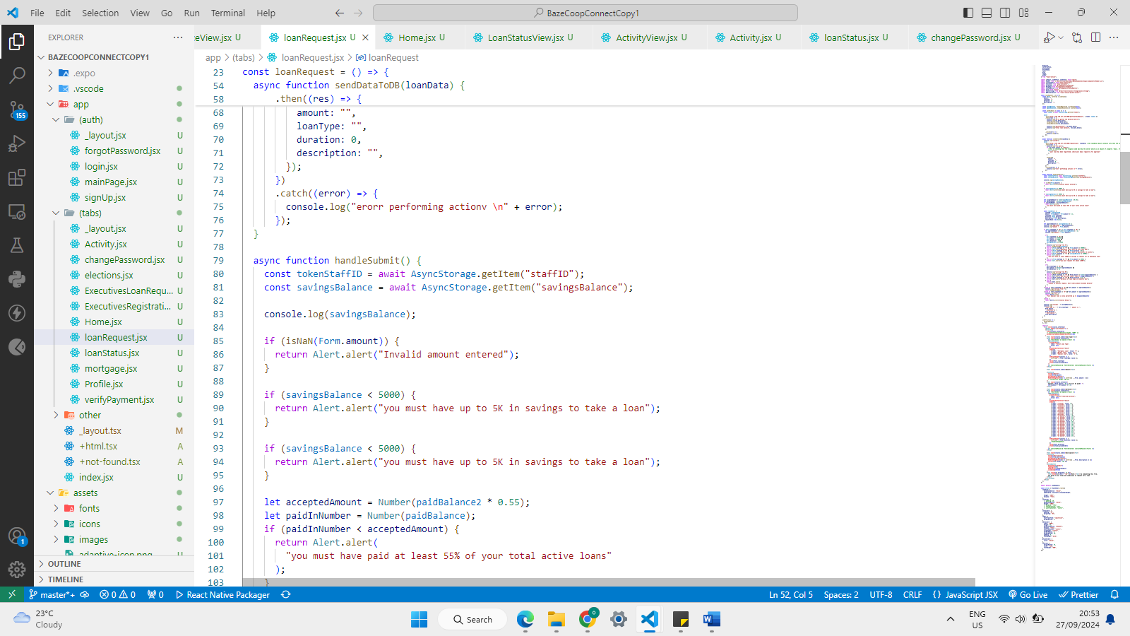

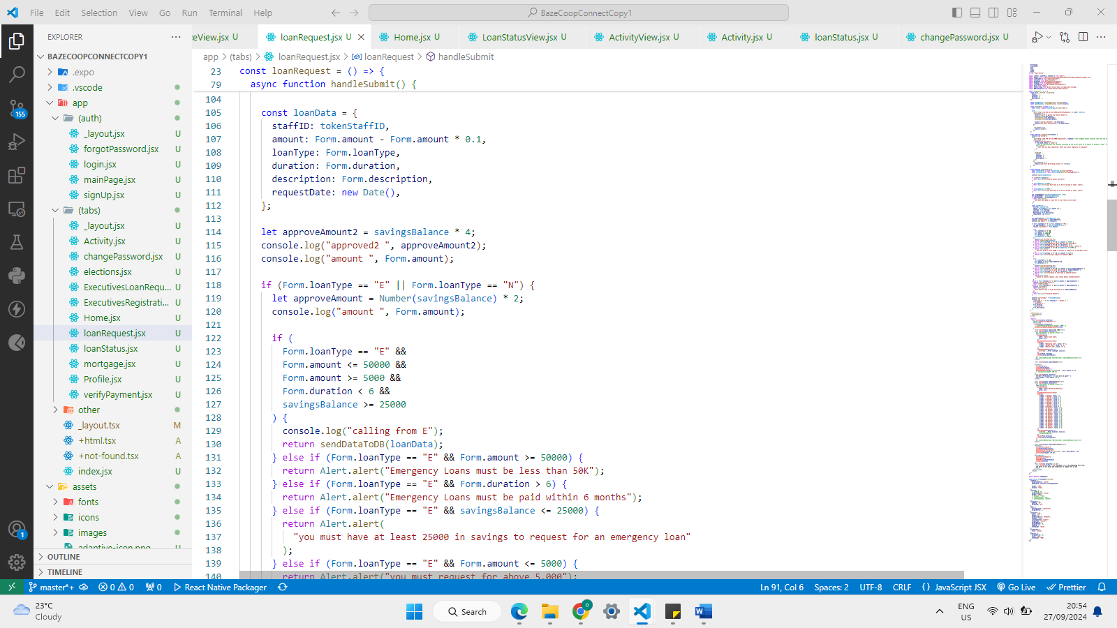

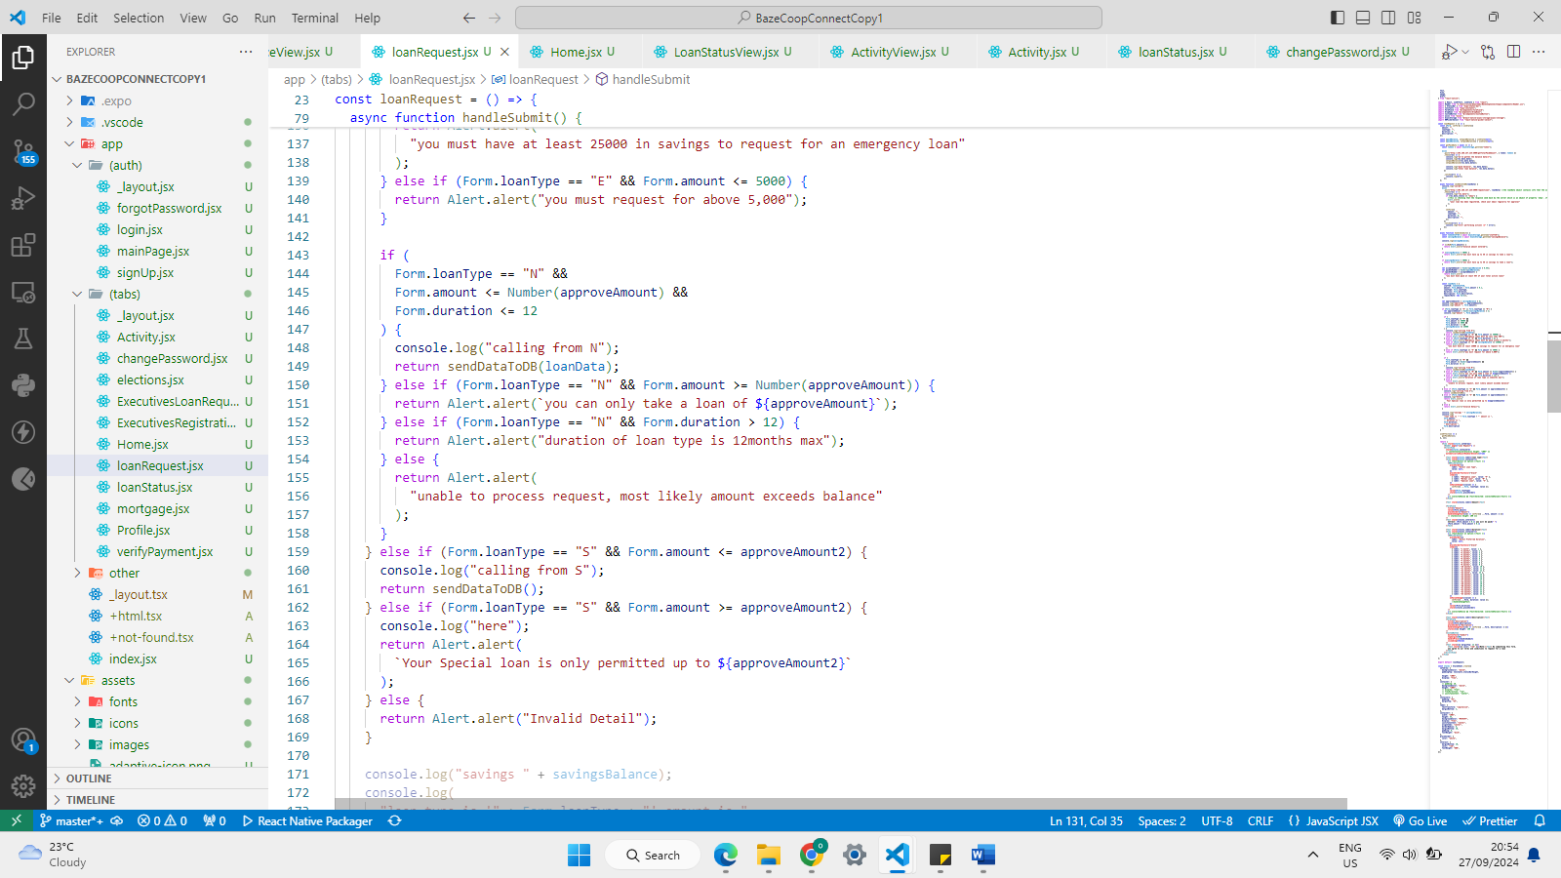

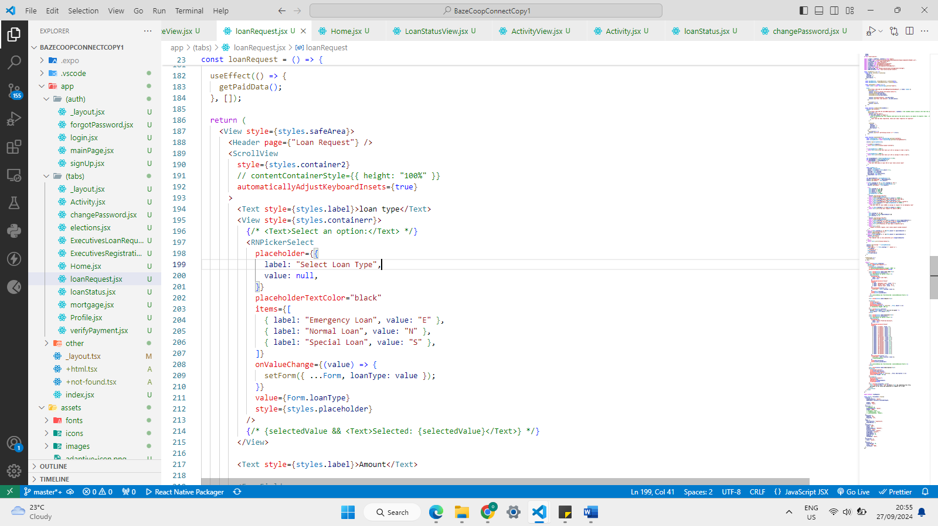

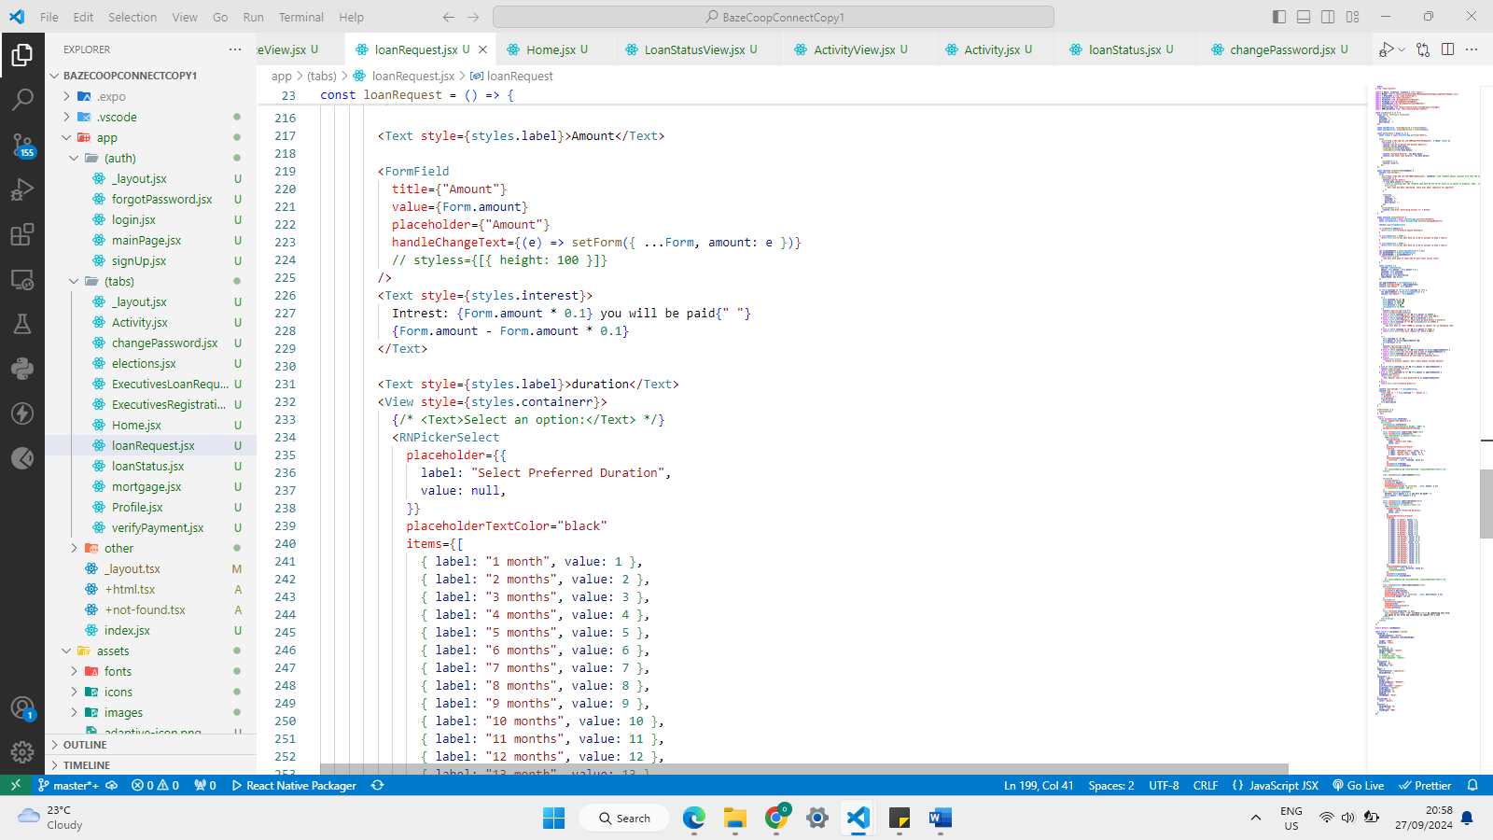

**Login Page**

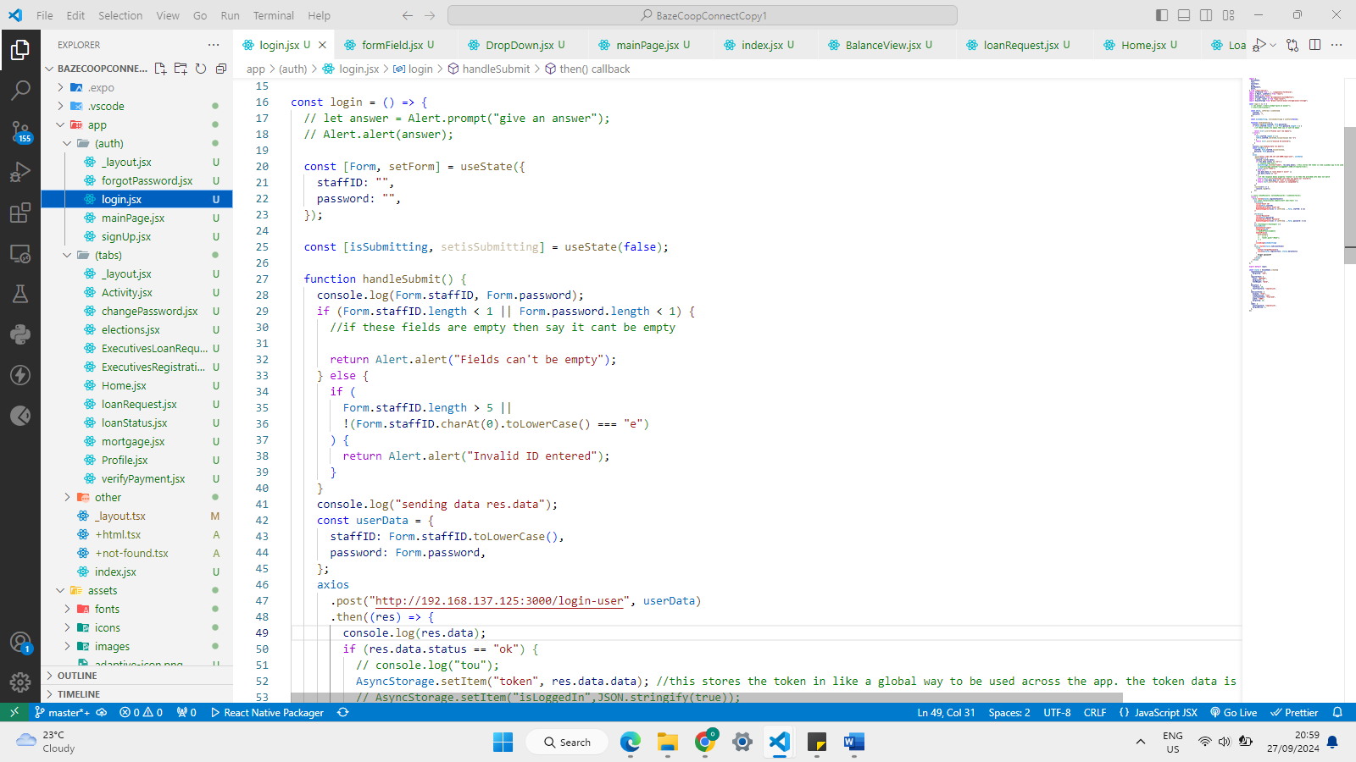

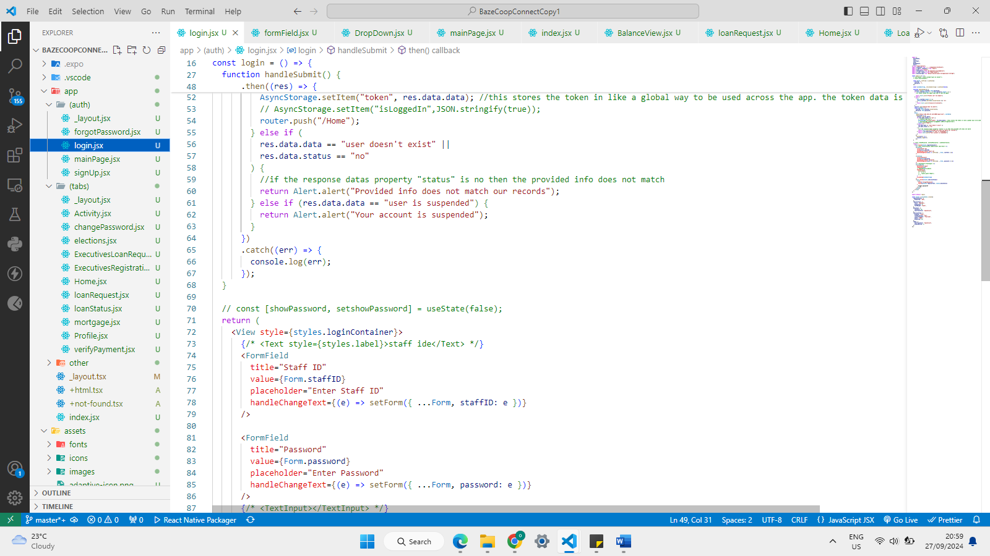

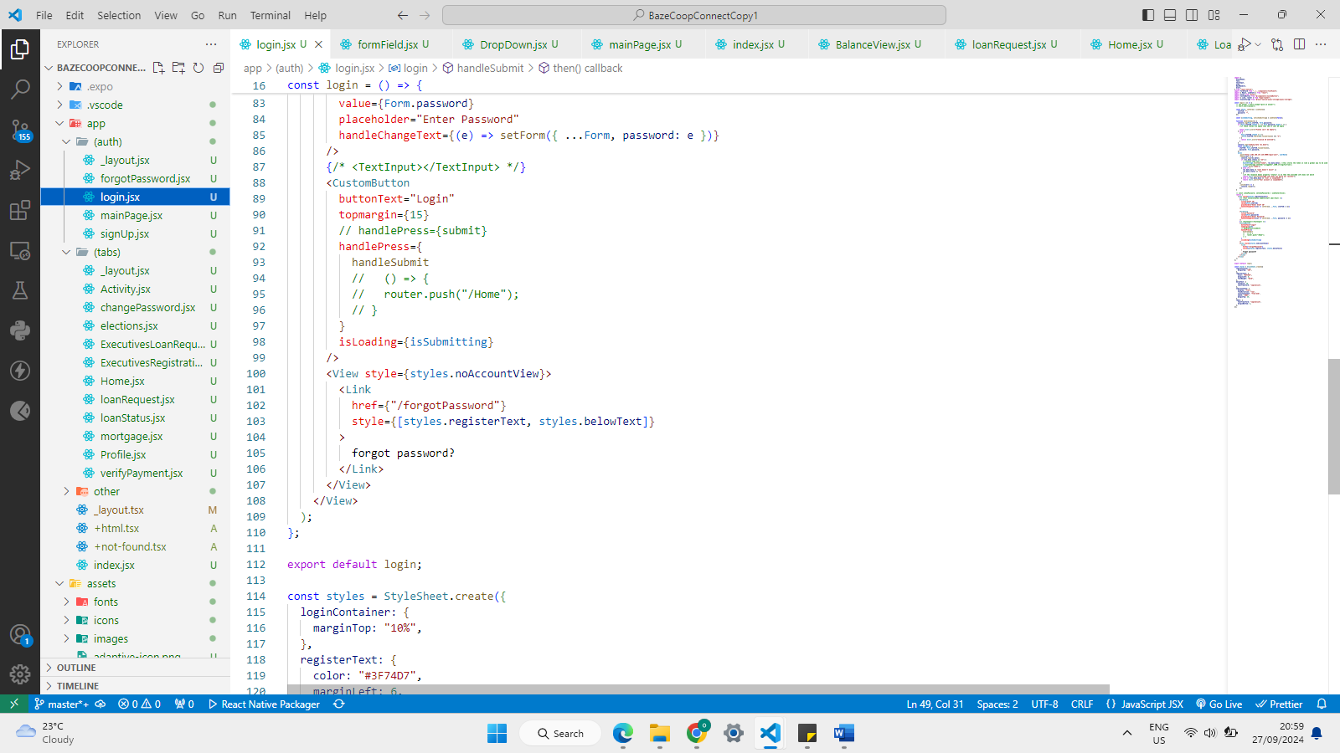

**Sign Up Page**

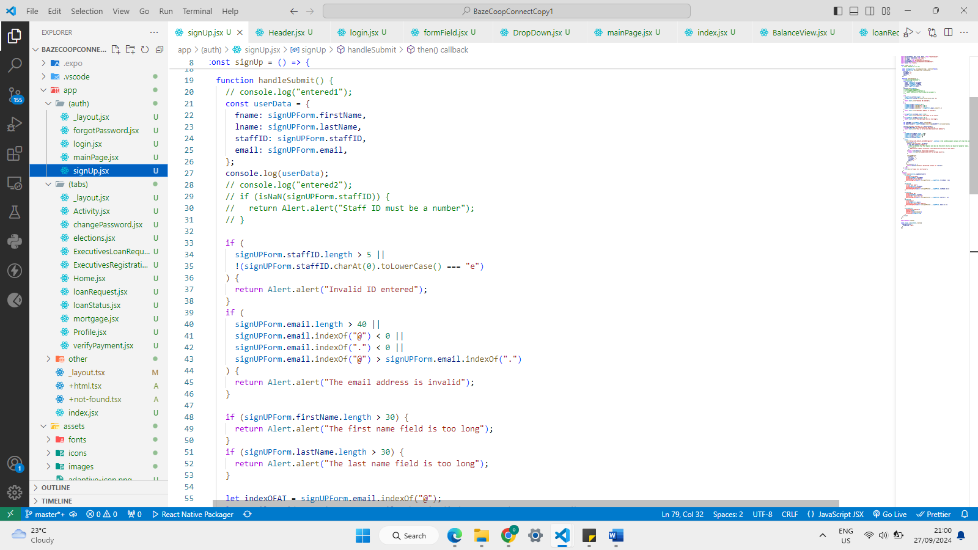

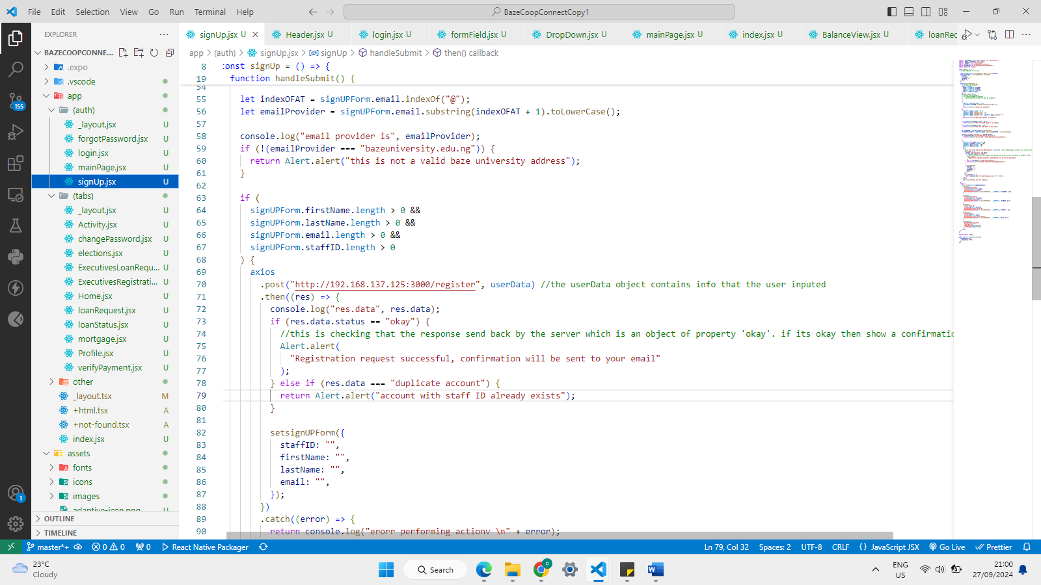

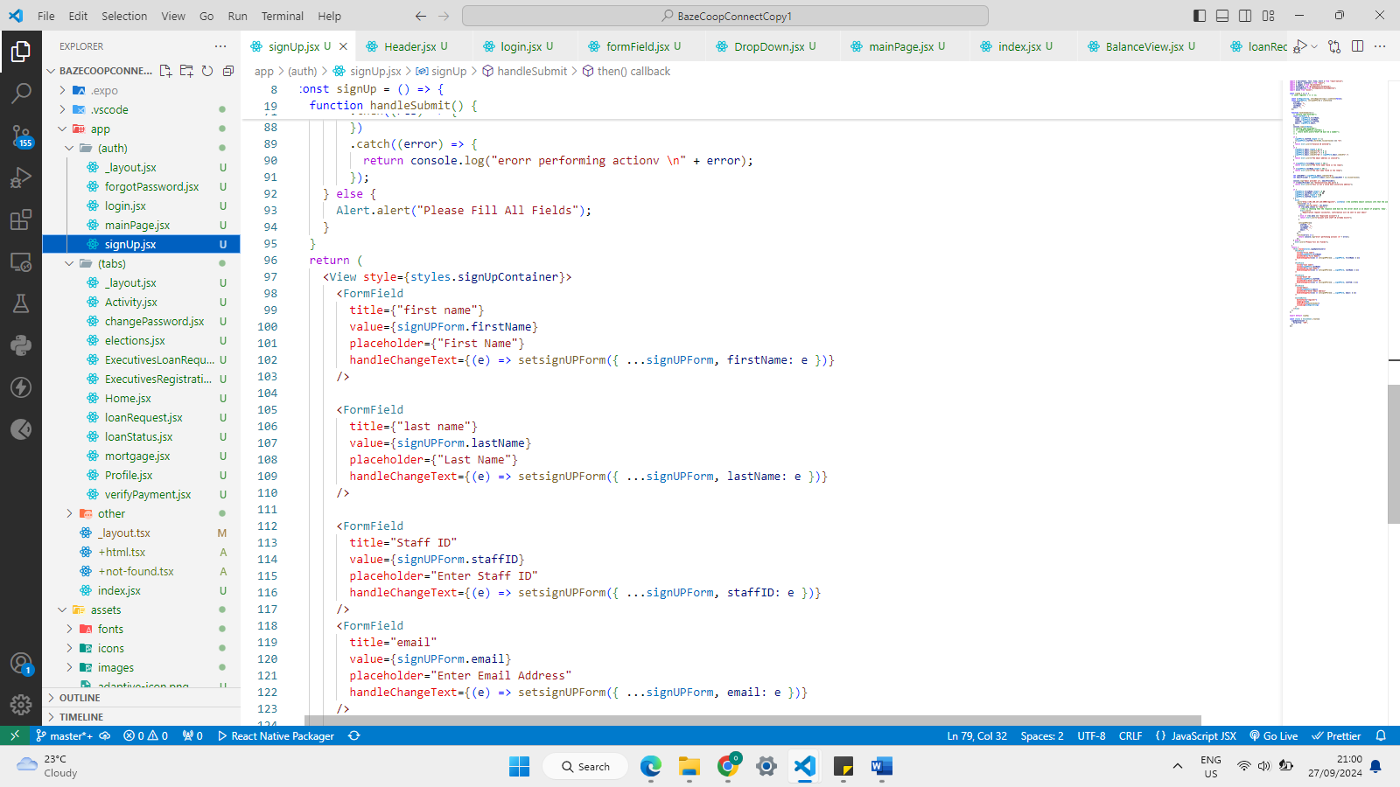

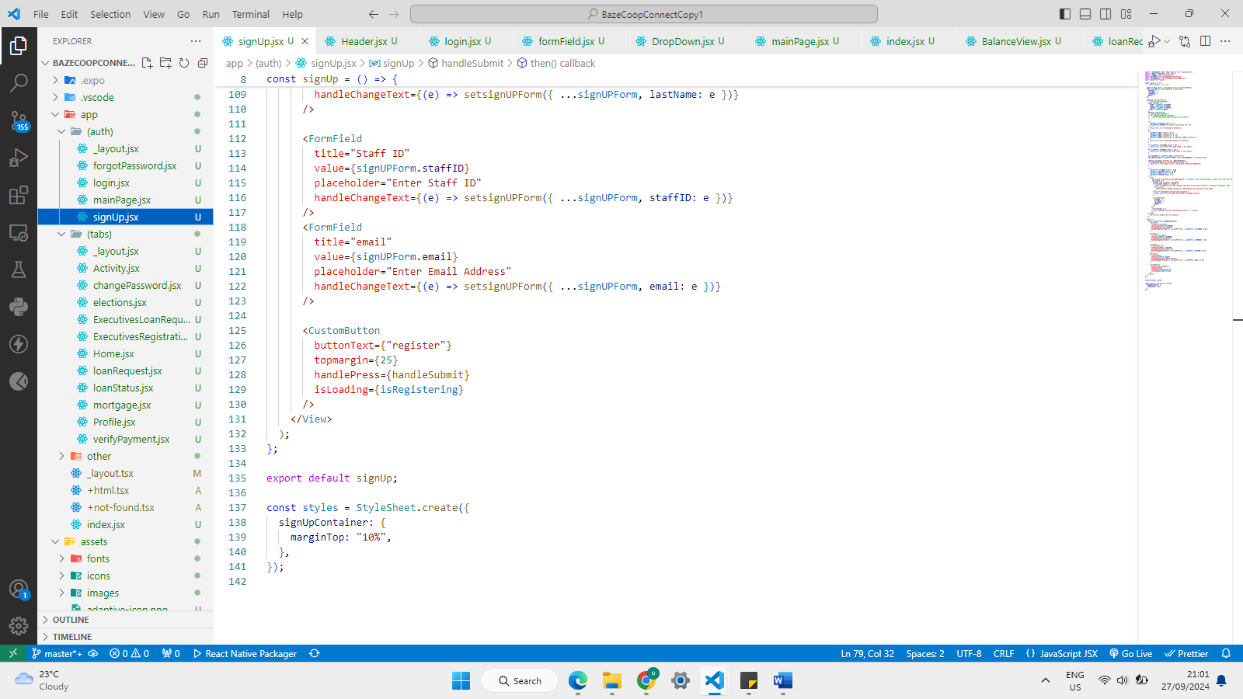

**Home-Page**

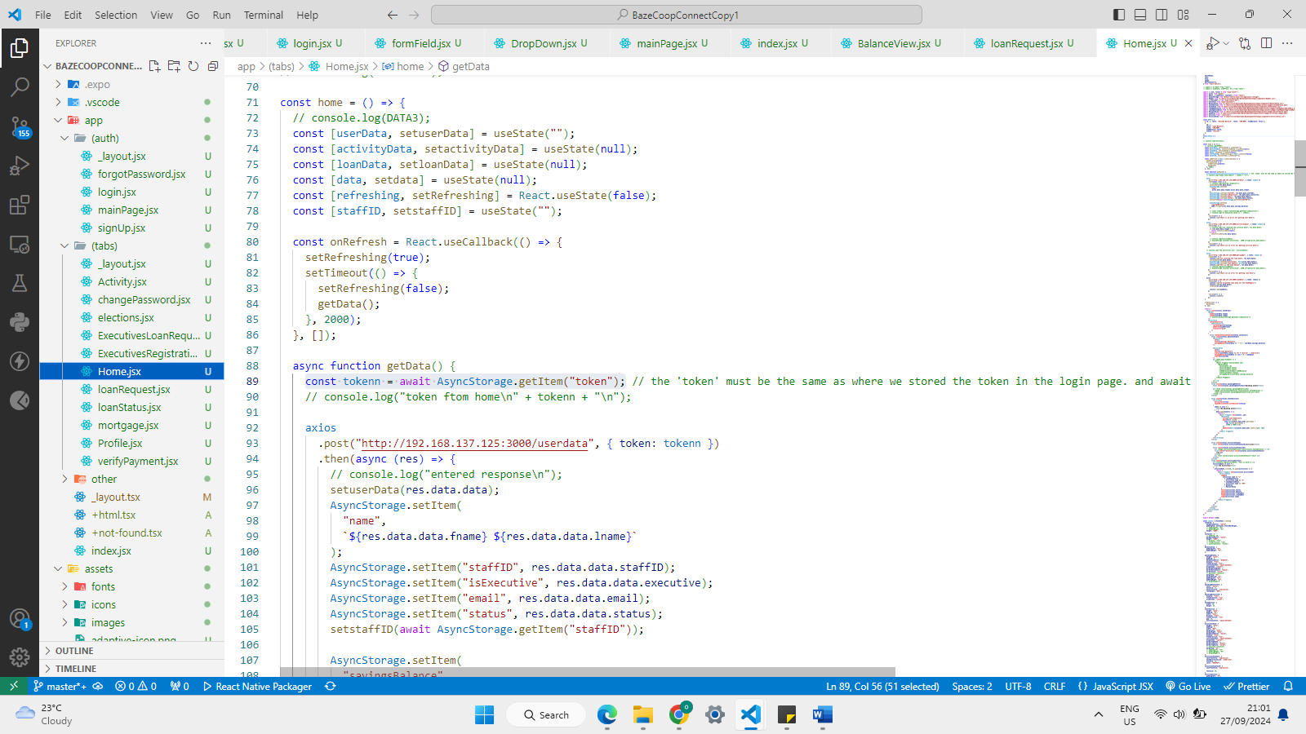

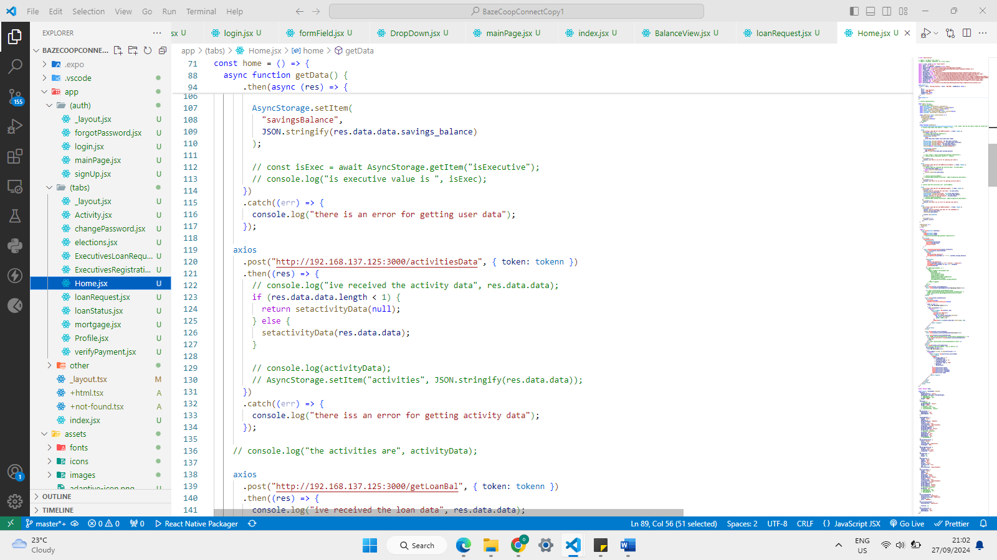

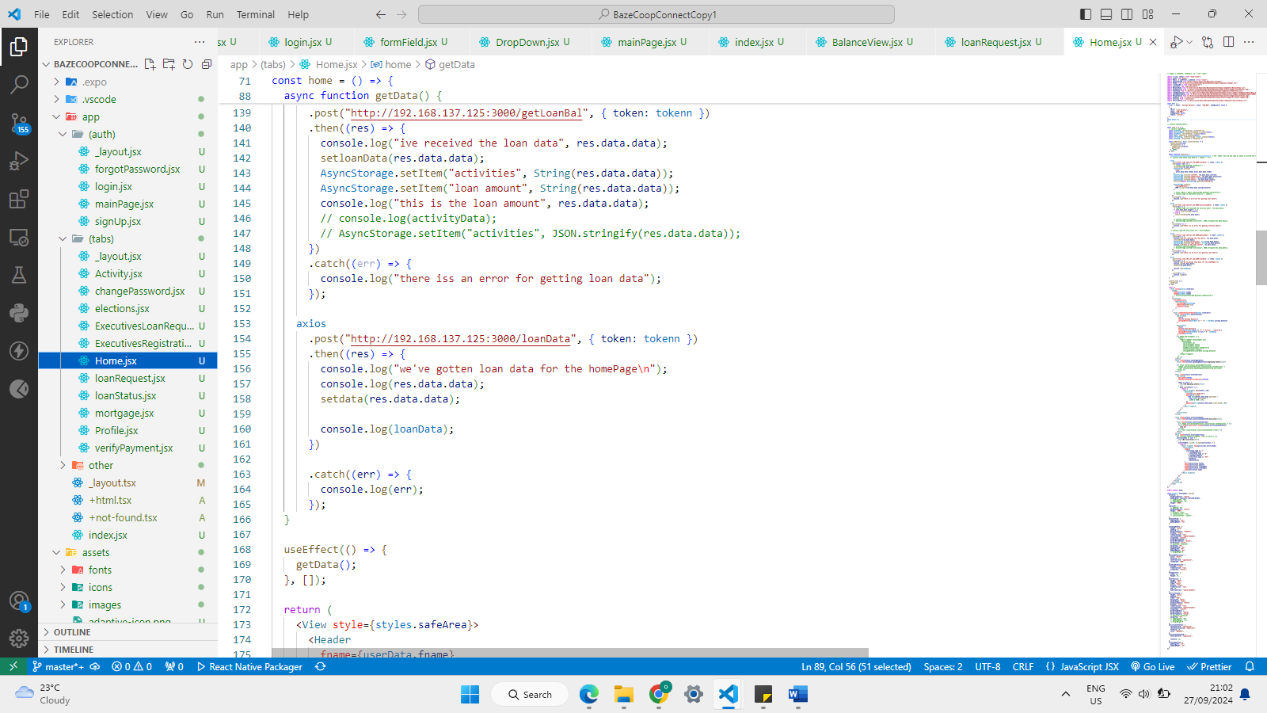

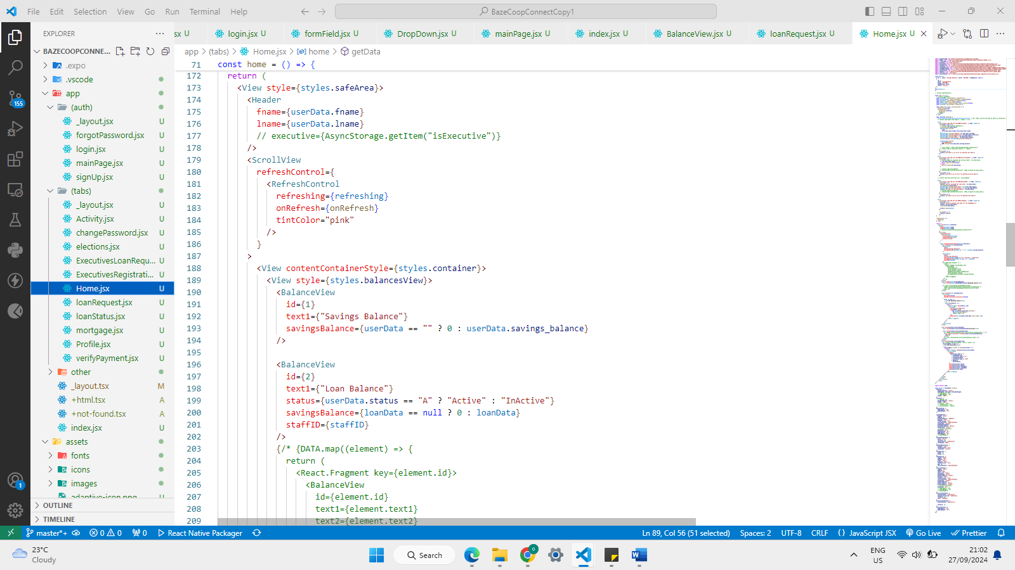

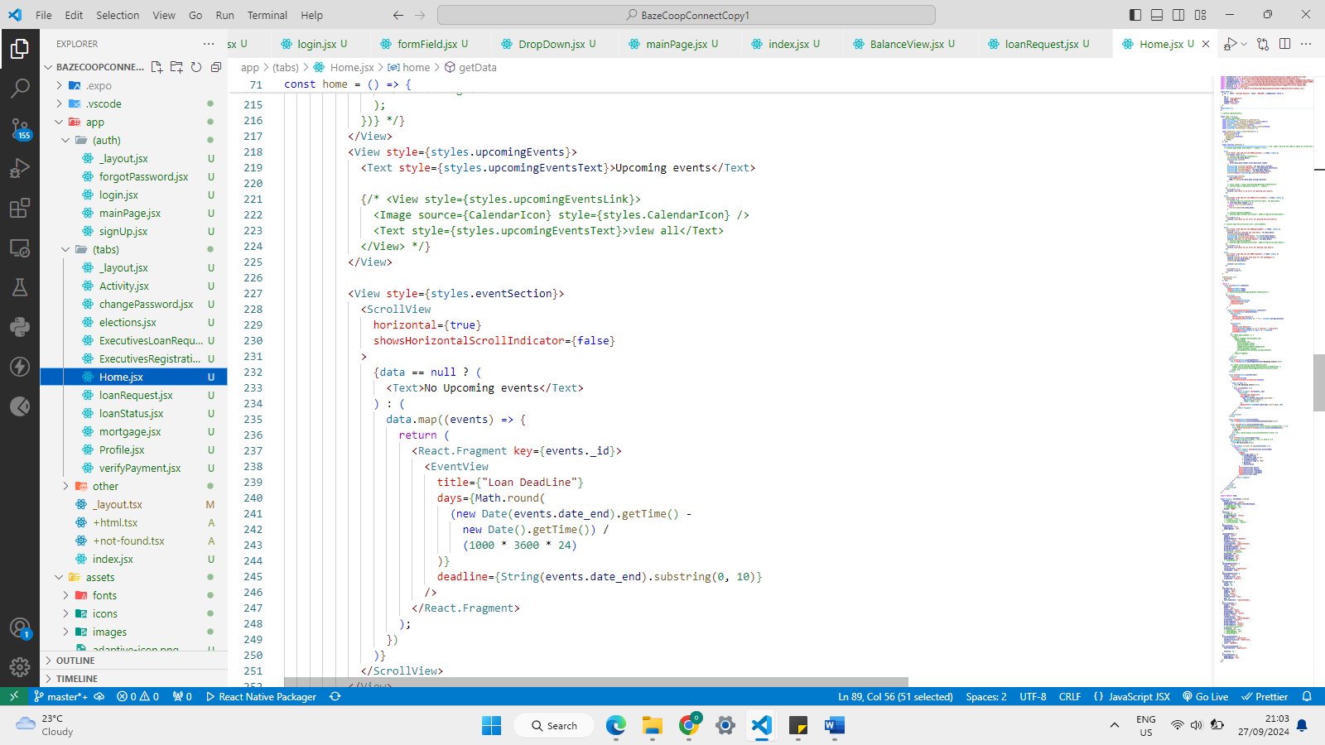

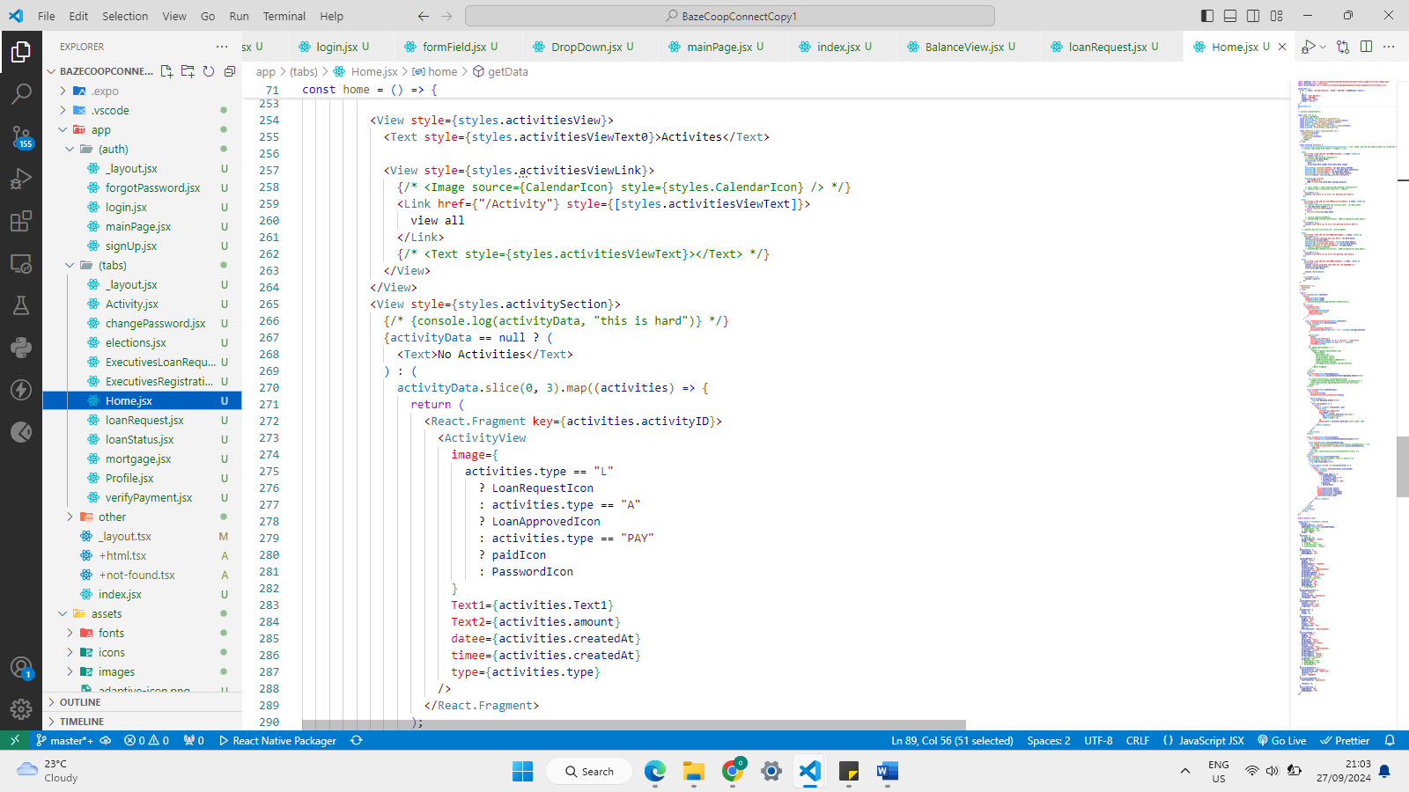

**Executives loan request page**

